MINUTES OF THE MEEETING OF CHUTE PARISH COUNCIL
HELD ON THURSDAY 2 MAY 2024
AT CHUTE VILLAGE HALL

41/24 OPEN FORUM
7 members of the public were present.

Gary King of Star House is concerned about a 1m square sinkhole which has opened up outside his drive. He reported the matter to WCC Highways on their app about 18 months ago and he was given a date for the repair of 22 June, but this job is now being shown as closed on the website, although no repair has been made. The hole is on the tarmacked highway. Cllr Harker offered to inspect this.

Mary Cummins asked when the white lines in Upper Chute were going to be repainted. Cllr Williams advised that the work is outsourced and that the job is on the schedule of works for the line painting team.

Huw Lovesey sent The Clerk a list of points he wished to raise prior to the meeting, which covered several matters discussed at the last meeting. These points included matters relating to ROW which were discussed by councillors as agenda items later in the meeting under footpaths and highways. The councillors thanked Huw for his regular footpath report.
Huw asked if the gulley clearance had taken place? Cllr Harker reported that it had not but that we have a date of 20 May. However, the gulley team has to cover 14 parishes in a 5-day period.

Huw made an overarching point about the inclusion of more detail in the minutes. Cllr Parr explained that at the previous meeting the Councillors had agreed with The Clerk that the minutes should be as succinct as possible as their purpose is to record the matters discussed and relevant decisions made, and they are not a verbatim record of public comments or the meeting. The Parish Council very much welcomes public participation and community engagement so long as the matters raised are relevant to council business.

John Turner asked if the owner of the Audi which persistently parks less than 30’ from the crossroads at the top of Forest Lane could be contacted and asked to park further away from the junction. This is a police matter. PCSO Ruby Rupinder will be asked to speak to the owner of the vehicle about this.

John Turner asked if proper tarmac passing places could be created when Hookwood Lane is resurfaced.

42/24 ELECTION OF CHAIRMAN AND VICE-CHAIRMAN
The Clerk asked who wished to stand for the role of Chairman and Vice-Chairman and both Cllr Wall and Jeremy Parr were unanimously re-elected to the respective roles by full council.

43/24 PRESENT
Cllr Wall (Chairman), Cllr Parr (Vice-Chairman), Cllr Hopton, Cllr Harker, Cllr Taylor, Cllr Alderson and Cllr Rudland were present. Cllr Williams (WCC) was present. The Clerk was in attendance.

44/24 APOLOGIES
There were no apologies.

45/24 DECLARATIONS OF INTEREST
There were no declarations of interest.

46/24 MINUTES OF THE LAST MEETING
The minutes of the last meeting held on 4 April 2024 were proposed by Cllr Alderson and seconded by Cllr Hopton. The minutes were then signed by the Chairman as a true record.

47/24 PLANNING
PL/2024/02791 Conholt Park - Alterations and refurbishment to courtyard stable (B4) - Support
PL/2024/03197 Conholt Park - As above and alterations to 2 ancillary buildings (B2 & B3) - Support

48/24 COUNTY COUNCILLORS/WILTSHIRE POLICE REPORTS
Cllr Williams submitted his report to The Clerk prior to the meeting and it is attached to the minutes.
PCSO Rhupinder Kaur did not attend the meeting but sent in a report which is attached to these minutes.

49/24 PARISH REPORTS
Highways (TH)
Notice has been given that Hookwook Lane will be closed for re-surfacing. Cllr Harker will request that proper passing places are created and tarmacked whilst the road is being resurfaced. He advised that WCC Highways are responsible for a traffic management plan to be operative whilst the work is undertaken. The gully team are coming out on 20 May. The Parish Steward has been asked to clear the accumulation of gravel that has amassed on our roads, and in particular at the bottom of Hookwood Lane. The repainting of white lines in the parish is on a waiting list with the team who undertake this work for WCC, so we will have to be patient. It has been noted that there has been a police presence in the parish.
Although not strictly a highways issue, the works by Pro-Drainage in Upper Chute have caused quite a lot of damage to the green. A written undertaking was given that they will restore the area when the works are complete. Susie Harries (via e-mail) asked if the pond can be restored but it was generally felt that it has never effectively held water, but it is a very useful soakaway. There is a damaged overhanging tree by the bus shelter that could fall so needs to be removed.
Footpaths/Rights of Way (AR/MA)
Cllr Rudland, as requested, had contacted Carys Hughes, ROW officer at WCC to find out the reasons for their request to remove the boulders and posts that run alongside the byway past Gammons Farm. She read out the content of this email. It was confirmed by WCC that it was a Highways matter.

The general consensus was that Robin Hallam had come to the last meeting to ask for the parish council’s support to retain the boulders and posts. The condition of the track has improved considerably since they have been in situ and Robin Hallam, with a contribution from the Forestry Commission, has been maintaining the track at his own expense. Robin Hallam is unaware that anybody in the locality has complained about the posts or boulders. If goodwill is lost, then maintenance may cease, and the track may revert to a state of poor repair. A vote was taken by the council as to whether support should be given to Robin Hallam’s request.
6 Councillors voted in favour of the motion to support Robin Hallam’s request for support. Cllr Rudland abstained.

The Parish Council would like to question the objection raised by the RofW officer. As a BOAT is technically a highway, the Clerk was asked to convene a site meeting with Wiltshire Highways to discuss the matter further. Cllr Williams recommended inviting Chris Clarke of WCC Highways to the meeting.

Cllr Rudland wanted to thank Simon Withers for repairing the stile on Chut17. The broken stile on Chut9 below Crystal Palace Farm has been reported to Jon Sykes and Finn Guinness as it is on the border of both their land and the landowners have been asked to repair it. Huw Lovesey was thanked for raising maintenance issues on Chut9 and Chut34 in his latest report.

Cllr Taylor reported that the terrain on the track from New Zealand to Cowdown (Chut34) is dangerous.

King George Playing Field (CW/TH)
Cllr Wall said the pavilion has a new floor but needs redecorating but the first quote was @ £5,000 which is ridiculously high. A new loo has been fitted. The container has been cleared to allow for storage of the fete equipment but there are now 5 mowers belonging to the Cricket Club which are blocking the rear of the container. A meeting with the Cricket Club will be arranged. The key for the John Deere is not available as we don’t want children to play on it.

It has been too wet to get the field treated but it has been spike aerated. All scrap metal should be offered to a salvage company. John Dawson has advised that he knows who left the plastic crate and will request that they remove it. The KGPF is currently in good shape financially, partly due to the outstanding work on the field not having been completed due to wet weather.

Village Hall (CW)
Cllr Wall reported that bookings have been good. Several windows need replacing so she has applied for a lottery grant to help fund the cost. It was agreed that the grant from the Parish Council to the VH should be increased this financial year from £150 to £1,000. The amount will be reviewed again next year.

Allotments (MT)
Cllr Taylor said the allotment site is looking good and Cllr Harker has removed the fallen tree. The Leylandii need reducing in height or removing. Cllr Harker said that SSE and BT must give prior notice to carrying out any tree works. BT came to look at installing new posts. The dead Ash trees need to be felled but as they are on a highway they belong to WCC who will be contacted about them. Jon Sykes has offered to supply a water bowser, which is very much appreciated.
Village Design Guide (MH)
Cllr Wall said that 12 copies of the VDG are being printed and will be available in the next week or so. Cllr Hopton also reported that a link to the Chute VDG is now available on the WCC website under Neighbourhood Planning.

50/24 FINANCE
The Internal Audit has been booked with John Murray for 13 May 24. The External Audit is with PKF Littlejohn LLP, although we will be eligible for exemption.

The 2023/24 year-end Accounts, bank reconciliation, corresponding bank statement and asset register were circulated to councillors prior to the meeting and were available to view at the meeting. The new notice board for Upper Chute has been added to the asset register, increasing the parish assets to £104,603.16. Valuations have been crossed checked against the parish’s insurance cover which is due for renewal in June 2024.
- The Certificate of Exemption 2023/24 Form 2 of the AGAR was reviewed and agreed by full council and was then signed by the Chairman and the Clerk.
- The Annual Governance Statement 2023/24 of the AGAR was read out in full and agreed by full council. It was then signed by the Chairman and the Clerk.
- The Accounting Statements 2023/24 of the AGAR were circulated to all councillors along with the year-end accounts. The figures were then agreed, and the form was signed by the Chairman and Clerk as a true record.
The Notice of Public Rights and Publication of the AGAR and Accounts will be posted on the parish website before 1 June 2024 in accordance with the dates and period recommended by the external auditors, PKF Littlejohn LLP. The inspection period will be from 3 June to 12 July 2024.
The Standing Orders and Financial Regulations remained unchanged from 2023 and were re-adopted by full council. The Chairman signed the documents in acceptance and The Clerk signed as witness.

There was no change to the Managerial and Financial Risk Assessment prepared by The Clerk in May 2023.

The Clerk requested permission to open a deposit account with Lloyds so the CIL funds could be ring-fenced. This was approved by full council.

Cllr Wall has obtained quotes for two replacement wooden village signposts, one at the bottom of Forest Lane and the other on Lower Chute green as they are both rotten. The sizes are to be confirmed but it was agreed in principle that they should be replaced. Cllr Wall will advise Chute Forest PC of the cost and ask them to make a contribution towards the signpost on the green in Lower Chute.

It was agreed to increase the grant to the Village Hall to £1,000 for this financial year and the matter will be reviewed again next year as it is not mandatory. It was unanimously agreed that the village hall is a great asset to the whole community.

The bank reconciliation and the corresponding bank statement for April were circulated to all councillors prior to the meeting. Parish Council funds were £18,502.03 reconciled to the April bank statement. The Chairman signed the bank reconciliation as a true record.
The record of payments made and received since the last meeting is as follows:

Payments Made:
27/04/2024 Clerks Salary – April £238.51
27/04/2024 HMRC – PAYE £ 59.58
Payments Received:
11/04/2024 Taylor – Allotment Rent £10.00
11/04/2024 Harker – Allotment Rent £10.00
11/04/2024 Gifford – Allotment Rent £10.00
11/04/2024 Gregory – Allotment Rent £10.00
17/04/2024 Cummins – Allotment Rent £10.00
19/04/2024 WCC - Precept £9,000.00
19/04/24 – CFPC Insurance £130.02
Payments for approval via online banking:
03/05/2024 BHIB Insurance Premium £ 789.56
03/05/2024 WALC Annual Subscription £ 146.58
03/05/2024 Clerks Expenses – Stationery £ 11.00
03/05/2025 KGPF Grant £2,700.00
03/05/2024 VH Grant (increased from £150) £1,000.00
03/05/2024 Simon Falla – Wellhead £ 910.94
27/05/2024 Clerks Salary – May £ 238.51
27/05/2024 HMRC – PAYE £ 59.58

The above payments were approved by full council.
51/24 CORRESPONDENCE AND ADMINISTRATION
Cadley well head is nearly complete and looks great. It is awaiting final installation. Simon Falla must be thanked for having done such a professional job without incurring huge expense.

The great crested newt issue concerning the pond in Chute Cadley seems to have come to a satisfactory outcome. Cllr Wall had a quote from an ecologist for £7,500 to carry out various surveys so she contacted Wild Earth Ecology in Stockbridge and met them at the pond. There is no water in the pond, so the ecologist was able to inspect the leaves and she concluded that the pond was not a breeding site for great crested newts and therefore no licence is required from the Natural England. All that is required is a method statement and a new fence to stop the newts from returning whilst restoration work is going on. The cost of this will be significantly less at £755. Wild Earth Ecology is also already working with Conholt Estate. As the pond is on parish council land, it will pay this fee from the CIL funds received once it has been confirmed that Conholt Estate are still happy to carry out the pond restoration work.

The land at the top of Forest Lane, Upper Chute where the laburnum tree fell is eligible to be registered with WCC as Local Green Space as it satisfies all the criteria. The Clerk has contacted WCC Planning who advised that the matter is for the Rights of Way Team, who advised that the matter is a planning department issue. Further communication is needed to establish which department is responsible for registering the land.

The green in Upper Chute is currently cut by at the Parrs’ but as they are moving from their property adjacent to the green back to Chute Standen, we need to find another volunteer who is prepared to cut the green. The land at the top of Forest Lane also needs to be cut regularly, so a request for help will be put out on the WhatsApp group and via the Chute Chronicle in that hope that someone will come forward and volunteer.

The meeting closed at 9.14pm.

The next Meeting of Chute Parish Council will take place on
Thursday, 6 June 2024 at 7.30pm in the Village Hall

Council Annual Report May 2024

Wiltshire Council’s Annual Report for Town and Parish Councils can be found at Resources for Town and Parish Councils - Democratic Services - Wiltshire Council

– here are some highlights.
Secure Finances – Investing in Key Services: Despite the ongoing budget pressures arising from increasing demand for services and inflationary costs, the Council has been able to effectively manage these challenges to ensure a firm financial footing. Key to this sustainable approach to delivering for Wiltshire Wiltshire, is to invest in services, especially those which tackle issues in a proactive way. The Council receives nearly 83% of its funding from local taxes, Business Rates and Council Tax, so we take delivering on our promises to local people very seriously.
Children’s Services – Outstanding Ofsted: We want to give Wiltshire’s children the best start in life as it is fundamental in improving their long-term life chances and gives them the best opportunity to live full and healthy lives. We have worked relentlessly to improve our services and now deliver consistently Outstanding services that ensure the needs of families and children are met at the right time by the right people. This is reflected in the Ofsted inspection report from November 2023 that rated us Outstanding across the board.
Additional Funding for Highways & Flood Prevention: Heat, flooding and severe winter weather has caused significant damage to some of Wiltshire’s roads in 2023. Whilst the overall condition of Wiltshire’s classified road network is better than the national average this continues to be a priority. We are investing an additional £10m in Highways maintenance, which together with increased Department for Transport (DfT) funding, will enable an extensive programme of road surfacing and treatment in 2024/25. We are also investing an additional £1m to support preventative drainage programmes and have confirmed additional £1.5m funding from 25/26 onwards to help with gully cleaning and potholes.
£179m for Adult Services, which includes over £9m of efficiency savings: Adult Social Care accounts for the highest percentage spend of Wiltshire Council’s budget and continues to see significant demographic and cost pressures. The Transforming Adult Social Care programme ensures that the Council is proactive in ensuring services meet need. Continued investment is being made in preventative, enablement and reablement services that support people to stay in their own homes and take full part in their communities. The Shared Lives Scheme, which offers a fostering style model of care and support continues to grow, and the use of Technology Enabled Care (TEC) is a key priority. Moving from children to adult services is one of the most critical times for anyone’s life, this is even more important for young adults who have Special Education Needs and Disabilities.
I have continued to support Parish and Town Councils and residents with specific local matters, and it has been a pleasure to attend Parish Council meetings across the area. I have also continued to chair Tidworth Area Board meetings, working with my fellow councillors on the priorities for our community area, Youth, Health and Wellbeing and Environment. Wiltshire Council devolves significant funding to the Area Boards for them to invest in local community projects and initiatives that meet local priorities and deliver exceptional outcomes for residents, please contact me if your organisation wishes to apply for a grant in the future.
I have now been a Wiltshire Councillor for 15 years and am still very much enjoying working on your behalf and happy to assist and hopefully resolve issues with local government. For Wiltshire Council this particularly means planning concerns, highway issues, waste and lots of other services provided by the Council.
Christopher Williams
Wiltshire Councillor for Ludgershall North & Rural
Tel: 07712159562 Email: christopher.williams@wiltshire.gov.uk


/



EL12 Ludgershall and Rural Police Report – April 2024
- Inspector 1619 Ricky LEE
- Sergeant 2687 Caroline RALPH
- Police Constable 2054 Jody KINGE
- Police Community Support Officer 6373 Rupinder KAUR

Pro-Active Work
- Johnson way, Ludgershall- ASB has been reported in area, enquiries are still on going. Patrols being conducted.
- Salisbury Plain- Few reports about dog attack as result either dogs are not on lead or sometimes people can’t control their dog especially on Salisbury plain, advice has been given about keeping your dogs on lead. Regular patrols of Salisbury plain being conducted.
- Recreation Road, Ludgershall- Unknown suspect(s) have damaged reporting person’s new build house. Appears suspect(s) have used some kind of object or weapon to damage the render and one windowpane. value £2,000. Enquiries are still ongoing. Patrol being conducted.
- Fittleton - a delivery driver for majestic Wines he was bitten by a dog, as they were opening the van to get the wine out, he noticed the owner coming from the house, he had approx. 3-4 dogs with him which came running towards him and one suddenly bit him above his left ankle causing injury. Enquiries are still ongoing. Patrols being conducted.
- Neighbourhood assisted response officer for following the report of RTC non injury in Everleigh.

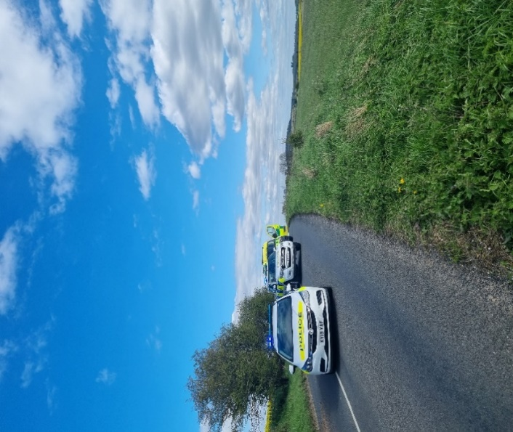
- MUGHAL TANDOORI, Ludgershall- Two unknown youths have thrown a glass bottle at a restaurant window causing it to smash. Enquiries are still ongoing. Patrols being conducted.
- Scout hut, Crown Lane, Ludgershall- Unknown suspect has smashed 2 windows. Patrols being conducted.
- Salisbury Plain, Everleigh- Unknown suspect has got into the reporting person’s trailer and other land rover taking their toolbox out of the back. Patrols being conducted in the area.
- Freeman drive, Ludgershall- 3 Unknown suspects have attempted to break into container belonging to MOD. Patrol being conducted.
- Wellesley Road, community centre Ludgershall- Unknown suspect(s) has smashed a window to a property at disused community centre to gain entry and then poured some unconfirmed liquid on the floors inside causing further damage. Enquiries are still ongoing. Patrols being conducted.
- Enford village hall- Unknown suspect(s) have gained entry to the RP's van by drilling holes near to the lock to unlock the central locking and open the door. Nothing has been stolen from the vehicle, but damage has been caused. Enquiries are still ongoing. Patrols being conducted.
- Local Neighbourhood team assisted response Officer who seized a large quantity of cannabis and equipment that had been dumped on the side of the road in Perham Down
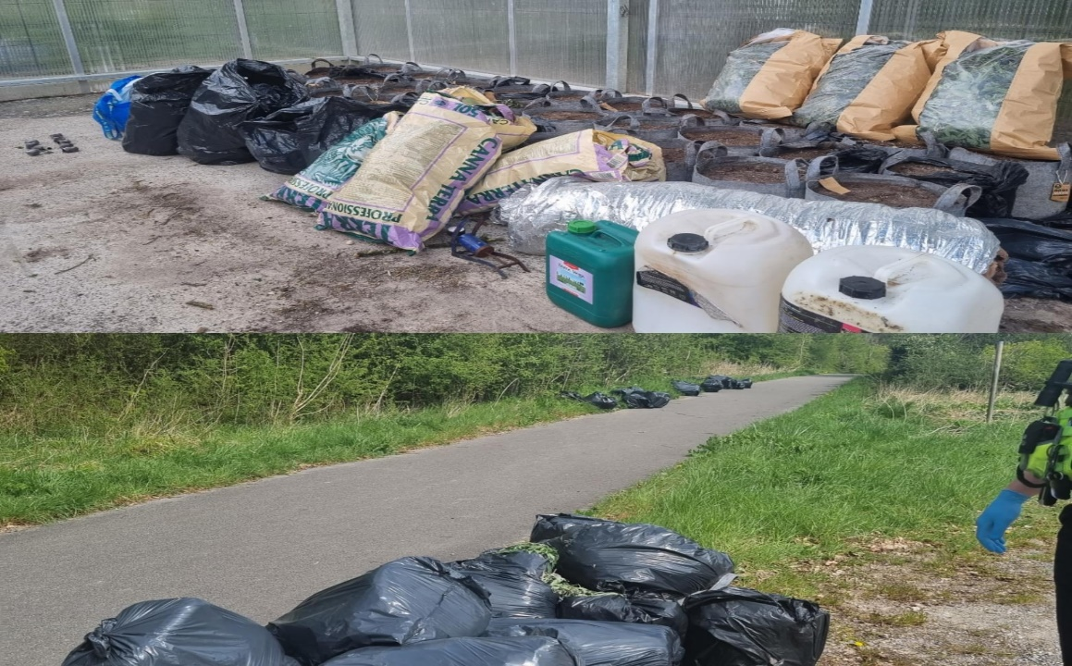

Community Speedwatch
Ludgershall (Tidworth Road)
Speed Enforcement caught 29 vehicles speeding on 5 April 2024 in Ludgershall on the Tidworth Road.
This stretch of road has a clearly displayed speed limit of 30mph. The fastest vehicle was captured travelling towards the traffic lights at 49mph. On the day in question, it was showery with occasional sunny periods.
Depending on previous convictions and history: -
24 drivers will be offered a speed awareness course
5 drivers will receive a Fixed Penalty Notice and 3 points.
Speed Enforcement caught a staggering 62 vehicles speeding over three separate sessions conducted on 10 April 2024 in Ludgershall on the Tidworth Road.
This stretch of road has a clearly displayed speed limit of 30mph. The fastest vehicle was captured travelling at 44mph. On the day in question it was overcast, turning to persistent rain.
Depending on previous convictions and history: -
57 drivers will be offered a speed awareness course
5 drivers will receive a Fixed Penalty Notice and 3 points.

Speed Enforcement caught 7 vehicles speeding on 19 April 2024 in Ludgershall on the Tidworth Road.
This stretch of road has a clearly displayed speed limit of 30mph. The fastest vehicle was captured travelling at 41mph. On the day in question, it was bright and dry but very windy.
Depending on previous convictions and history, 7 drivers will be offered a speed awareness course.
Proceedings will now be undertaken to ensure the most appropriate outcome for the offenders takes place.

Collingbourne Kingstone (Cuckoo Pen Railings)
Speed Enforcement caught 11 vehicles speeding on 5 April 2024 in Collingbourne Kingston near the Cuckoo Pen. This stretch of road has a clearly displayed speed limit of 30mph. The fastest vehicle was captured approaching the bend at a staggering 49mph. On the day in question, it was showery and roads were wet.
Depending on previous convictions and history: -
10 drivers will be offered a speed awareness course
1 driver will receive a Fixed Penalty Notice and 3 points.
Speed Enforcement caught 3 vehicles speeding on 19 April 2024 in Collingbourne Kingston near the Cuckoo Pen. This stretch of road has a clearly displayed speed limit of 30mph. The fastest vehicles were captured travelling at 40mph. On the day in question, it was dry and bright.
Proceedings will now be undertaken to ensure the most appropriate outcome for the offenders takes place.

Community Engagement
- PCSO, along with the early intervention team, attended the Netheravon primary school in Netheravon to deliver school talks about ‘Online safety’ to Year 5 and year 6.
- Local PC and PCSO conducted patrols In Ludgershall, Chute, Collingbourne, Nteheravon Enford, Everleigh: Engaging with Local farmers and local businesses, providing updates and a visible presence.
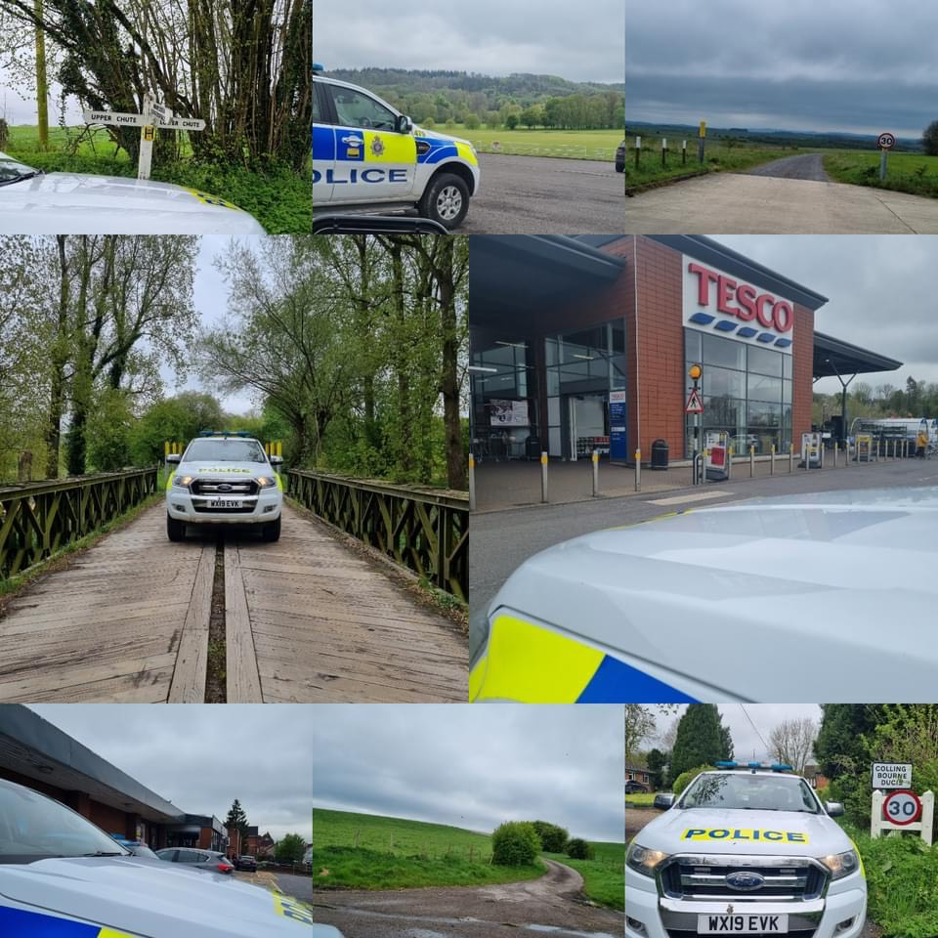
- The local PCSO attended the coffee mornings in Ludgershall and engaged with the local community.
- The local PC and PCSO attended Enford Farm. Enford, West Hill Farm Everleigh, and Collingbourne Kingston engaged with farmers and heard their concern about hare coursing poaching.
- The local PCSO and PC held the community consultation in Enford.
- Local PCSO and PC attended coffee mornings and hold the community Consultation in Netheravon and engaged with the local community in Netheravon.

OP RECALL
We want to take the time to pass some important messages regarding livestock worrying and what you can do to stop it from happening:
• Keep dogs on a short lead when around livestock.
• Clear up after your dog as faeces can harm cattle and sheep – and humans too!
• Remember your actions can affect other people's lives and livelihoods.
• Tampering with farm signs and electric fences that are intended to everybody keep safe could have serious consequences.
• Please do not remove signs that are there to keep people safe and always leave gates how you found them - or follow instructions on signs on gates.
• If you see a dog or dogs chasing livestock please call 999 and provide as much information as possible.
• Photo or video evidence of any dogs may help if you can do so safely.

Priority Patrols
- Ongoing reassurance patrols around Upper Chute and Chute area for following the ASB and Nuisance reports.
- Regular reassurance patrols of Recreation Road, Ludgershall for following the report of Criminal Damage.
- Regular reassurance patrols of Wellesley Road, Ludgershall for following the report of Burglary.
- Regular reassurance patrols of MUGHAL TANDOORI, Ludgershall for following the reports of criminal damage.
- Regular reassurance patrols of Enford for following the reports of vehicle has been broken into and damage been caused.
- Regular reassurance patrols of Salisbury Plain for following the reports of vehicle has been broken into and dog attacks.
- Regular reassurance patrols of Johnson Way, Ludgershall for following a report of ASB.
- Regular marked vehicle patrols targeting Rural Crime, Poaching, Fuel theft, Hare Coursing in Enford farm, Collingbourne Ducis Farms, Collingbourne Kingston Southgrave farm, West Hill farm in Everleigh, Nertheravon and Haxton farm.
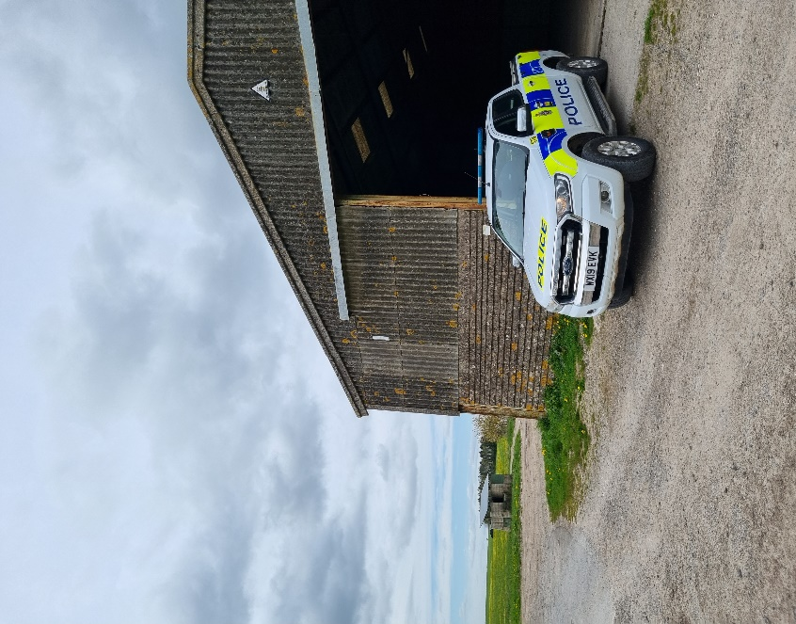

Numerous other activities have been carried out, which cannot be disclosed for operational reasons

Reporting Incidents or Intelligence

At Wiltshire Police, we have a number of ways you can report crime or incidents

- Via our online reporting hub https://www.wiltshire.police.uk/ro/report/
- Via 101 for non-emergencies and the drink drive hotline.
- Via 999 for crimes in progress and immediate threats or danger
- Via the Amesbury email inbox AmesburyAreaCPT@wiltshire.police.uk
- Directly to your Neighbourhood Policing Team via email

amesburyareanpt@wiltshire.police.uk

You can also view a crime and incident map for your area; this will show you crimes and incidents that have been reported https://www.police.uk/pu/your-area/wiltshire-police/amesbury/

