MINUTES OF THE MEEETING OF CHUTE PARISH COUNCIL
HELD ON THURSDAY 2nd JANUARY 2025
AT CHUTE VILLAGE HALL

01/25 OPEN FORUM
1 member of the public was present.

Huw Lovesey had submitted an updated footpath report which was circulated to councillors prior to the meeting. Chut14 on Hatchet Hill needs a new entrance fence as the current railings have collapsed. Chut13 further up the hill does not have a fence at the entrance as the visibility is better and it is not on a steep hill.

02/25 PRESENT
Cllr Wall (Chairman), Cllr Parr (Vice-Chairman), Cllr Harker, Cllr Hopton and Cllr Rudland. The Clerk was in attendance.

03/25 APOLOGIES
There were apologies from Cllr Alderson and PCSO Rhupinda Kaur. Cllr Taylor did not attend the meeting. Cllr Williams (WCC) is away until 6 January so did not attend.

04/25 DECLARATIONS OF INTEREST
None.

05/25 MINUTES OF THE LAST MEETING
The minutes of the last meeting held on 7th November 2024 were proposed by Cllr Harker and seconded by Cllr Rudland. The minutes were then signed by the Chairman as a true record.

06/25 PLANNING
PL/2024/08205 Change metal single glazed window to hardwood double glazed at Chute VH - Advisory

07/25 COUNTY COUNCILLORS/WILTSHIRE POLICE REPORTS
Cllr Williams was on holiday so had not submitted a written report to the Clerk prior to the meeting.

The local police report by our PCSO’s was submitted prior to the meeting which was circulated to councillors and is attached to these minutes.

08/25 PARISH REPORTS
Highways (TH)
Cllr Harker said that the resurfacing of Hookwood Lane has been done but the passing places need the edges softening as the drop off the edge of the tarmac onto the verge could damage a car wheel. The new sign is now installed at the bottom of Forest Lane but still needs a couple of finger posts fitting. Thank you to Huw Lovesey and Rick Wall who both helped Cllr Harker with installing the new sign.
Cllr Harker said he has received requests from residents to look at getting the road in Upper Chute from the corner of the green at the crossroads up past Fosgate House, past Parsonage Farm to The Old Vicarage resurfaced once all the building work has been completed.
The parish steward schedule has been received, and we get Kevan for 1.5 days per month for Chute Parish.
The Conholt Estate renovation project is still causing increased traffic and on-going damage to our roads and verges. The Clerk will write to Danny Kruger MP to find out how we get the damage repaired at the end of the project as there was no traffic management plan stipulated in the main planning application for Conholt.
Footpaths/Rights of Way (AR/MA)
Chute 9 – There has been no further action taken regarding this to date.
Chute 14 – The fencing on the road verge needs to be repaired or replaced as identified by Huw Lovesey.
Chute 15 – A second step has been added to the stile which makes it far safer and easier to use. Thank you to the landowner for doing this.

King George Playing Field (CW/TH)
Cllr Wall reported that teenage vandals have broken the mobile goal posts. She is seeing if they can be repaired. This is unfortunate and involves the playing field in unnecessary expense.

Village Hall (CW)
Cllr Wall reported that the evening with Tom Bower had been a success and made a £400 profit towards the running of the hall. The Christmas Lunch as also well attended with 45 participants but in general the hall is currently very quiet for bookings. The new windows are being installed in February.

Allotments (MT)
There are potentially 3-4 plots available at the allotment site. The Clerk will put a separate article in the Chute Chronicle to advertise them as there has been no interest to date.
09/25 FINANCE
The draft budget was circulated to all councillors prior to the meeting for review. A grass cutting quotation for all the Upper Chute greens has been received and added to the budget in the amount of £2,193.37 per year with mowing and strimming every 2 weeks from April to September. It was discussed that the precept should be increased from £9,000 to £12,700 and this was agreed by full council. It was noted that the precept had not been increased over the last 4 years. The precept request form from WCC was duly completed and signed by The Clerk/RFO and The Chairman.
The bank reconciliation and the corresponding bank statements for November and December was circulated to all councillors prior to the meeting. Parish Council funds were £7,976.99 with £5,187.98 in the current account and £2,789.01 in the deposit account and these figures reconciled to the bank statement. The Chairman signed the bank reconciliation as a true record.

The record of payments made and received since the last meeting is as follows:

Payments Made:
08/11/2024 Royal British Legion £ 40.00
14/11/2024 WelMedical – new AED pads for The Hatchet £ 80.28
21/11/2024 Rick Wall – Expenses £ 4.80
21/11/2024 Tim Harker – Expenses £ 7.00
27/11/2024 Clerks Salary – November £260.00
27/11/2024 HMRC – PAYE £ 65.00
04/12/2024 One.com Subscription £101.84
27/12/2024 Clerks Salary – December £260.00
27/12/2024 HMRC – PAYE £ 65.00
Payments Received:
None
Payments for approval via online banking:
27/01/2025 Clerks Salary – January £260.00
27/01/2025 HMRC – PAYE £ 65.00
The above payments were proposed by Cllr Parr and seconded by Cllr Harker.
10/25 PARISH IMPROVEMENT PROGRAMME
Area at the top of Butts Hill. Cllr Wall will ask the ecologist who worked with on the restoration of the Chute Cadley Pond for landscaping advice. Ideally, we would like to obtain drawings showing two planting schemes for residents to vote on, but it is proving hard to find anybody to produce these.

Cllr Wall obtained three quotes to pollard the Lime tree on Chute Cadley Green. It was agreed to use Walsh Tree Services at a cost of £450 + VAT. This expenditure was proposed by Cllr Harker and seconded by Cllr Rudland. The Chestnut tree in Upper Chute has a bit of die back but is otherwise healthy.

11/25 CORRESPONDENCE AND ADMINISTRATION
Cllr Rudland is looking into how the land at the top of Butts Hill can be registered in the name of the parish as it does not fit the criteria for a village green.
The Clerk will accept the quotation in the amount of £450 + VAT from Walsh Tree Services to pollard the Lime tree on Chute Cadley Green.
The Clerk will accept the quotation of £2,193.37 from Kevin Bowler to cut the greens in Upper Chute from April to October and decline the quotation of £2,097.60 + VAT to cut the playing field and play area.

The meeting closed at 8.43 pm.

The next meeting of Chute Parish Council will take place on
Thursday, 6th February 2025 at 7.30pm in the Village Hall





EL12 Ludgershall and Rural Police Report – December 2024

- Inspector1359 Gavin BREWSTER
- Sergeant 2687 Caroline RALPH
- Police Constable 2054 Jody KINGE
- Police Community Support Officer 6373 Rupinder KAUR

Pro-Active Work

- Coombe lane, Enford– Unknown suspects have attempted to open the sides of a garage door, however no entry gained, and nothing stolen. Enquiries are still ongoing. Patrols being conducted

- Ludgershall- Unknown suspect has stolen a parcel from doorstep. value of parcel £75.00. Enquiries are still ongoing. Patrol being conducted.

- Coombe Lane, Enford-Unknown suspect has gained entry to a van parked on a driveway and have stolen tools and copper approx. value £5000.Enquiries are still ongoing. Patrols being conducted

- Ludgershall- Unknown suspect caused scrape to driver's side door of the vehicle. Damage approx. value £220-230. Patrol being conducted

- Netheravon-Unknown male has carried out 5 transactions using fake Scottish £50 notes to the value of £800-£850. Patrol being conducted.

- Everleigh: - Unknown suspect(s) have smashed the passenger side window of the vehicle and have stolen Christmas presents £10 and various other items from the vehicle. Damage caused to vehicle approx. value £115.Enquiries are still ongoing. Patrols being conducted.

- Salisbury Plain: - Unknown suspect has set the fire of the vehicle parked on Salisbury Plain. Fire brigade extinguished fire but car a write off. Patrol being conducted
- Enford farm, Enford- Unknown- Numerous time unknown persons have been using dogs and lamps on the field, believed for hare coursers/poachers. Patrols being conducted.

- Highbury, Andover Road, Ludgershall: - Unknown company has arranged to do some guttering work for the reporting person. The company has come over the course of a few days but only completed knocking down her shed and doing some work to her patio which was not part of the agreement, the guttering did not get sorted. The males stated that she owed them £520 which she agreed to as she felt scared and wanted them gone. A verbal agreement was arranged for her to bank transfer this. Advice has been given to reporting person about rogue traders and scams Patrol being conducted

- CO-OP/ Tesco, Ludgershall: - Crime prevention advice has been given to COOP/ Tesco on recent scams about gift cards. Patrols being conducted.
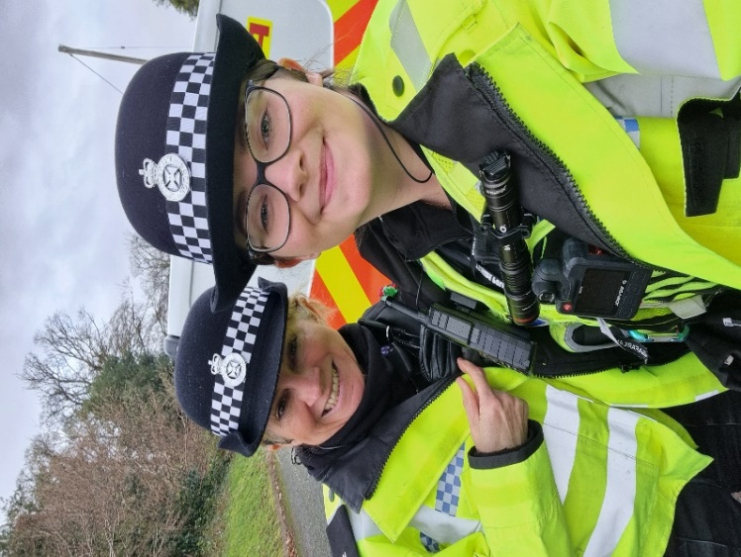
Community Engagement
- Local officers conducted the foot patrol and mobile patrol of the hotspot of ASB in Ludgershall, Larkhill, Collingbourne Ducis, Netheravon.

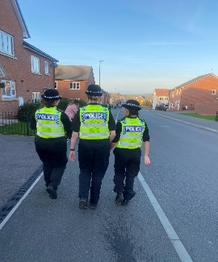

- Attended the CO-OP/ Tesco in Ludgershall to give advice about scams. Engaged with the staff and gathered intel.

- Local officer has done proactive patrols of farm, and engaged with farmer also gave the crime prevention advice to farmers.
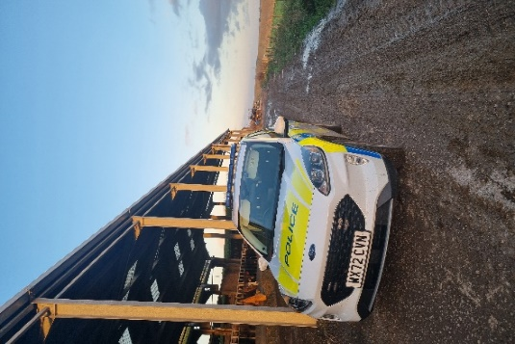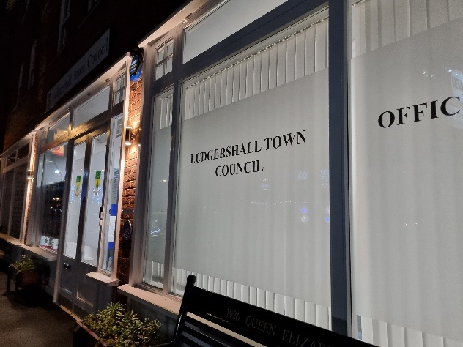

- Local officer attended the Ludgershall, Everleigh town council meeting in December, engaged with the councillors and public also discussed their concerns.

Speed Enforcement

- Tidworth Road Ludgershall- Speed Enforcement caught 7 vehicles speeding on 13 December 2024 in Ludgershall on the Tidworth Road. Unfortunately, a second site on Andover was unenforceable due to parked cars.
- Tidworth Road has a clearly displayed speed limit of 30mph. The fastest vehicle was captured travelling at 42mph. On the day in question, there was light but persistent rain and roads were wet.
- Depending on previous convictions and history, 7 drivers will be offered a speed awareness course.
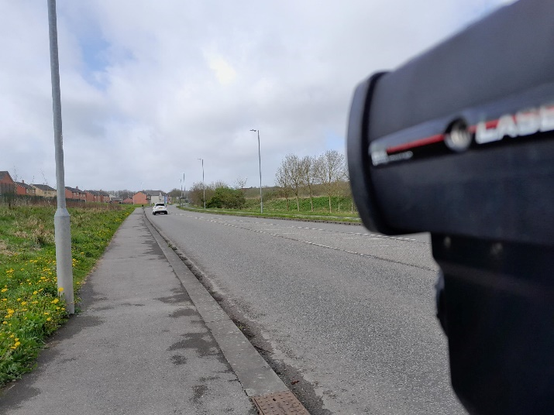

- Collingbourne Ducis- Speed Enforcement caught 15 vehicles speeding over the course of 25 minutes on 13 December 2024 in Collingbourne Ducis near the junction with Everleigh Road.
- This stretch of road has a clearly displayed speed limit of 30mph. The fastest vehicle was captured entering the village at 47mph. On the day in question, there was persistent light rain and roads were wet. The planned enforcement session had to be curtailed due to the inclement weather.
- Depending on previous convictions and history: -
12 drivers will be offered a speed awareness course
3 drivers will receive a Fixed Penalty Notice and 3 points.
Proceedings will now be undertaken to ensure the most appropriate outcome for the offenders takes place.
Priority Patrols

- Ongoing reassurance patrols around Upper Chute and Chute area for following the ASB and Nuisance reports.
- Regular reassurance foot patrols of Ludgershall for following the reports of scams and rogue traders.
- Regular reassurance patrol of Collingbourne Ducis, Churchyard for following the report of ASB.
- Ongoing reassurance patrol of Collingbourne Woods, Ludgershall for following the report of drug activities in the area.
- Ongoing reassurance patrol of Salisbury Plain for following the report of vehicle was set on fire.
- Ongoing reassurance patrol of Coombe Lane, Enford for following the report of breaking.
- Regular marked vehicle patrols targeting Rural Crime, Poaching, Fuel theft, Hare Coursing in Enford farm, COLLINGBOURNE DUCIS Farms, COLLINGBOURNE KINGSTON farms, Everleigh farms, Netheravon and Haxton farm, Enford farm.

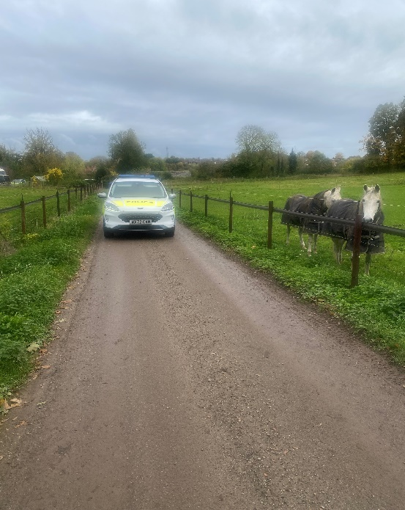

Numerous other activities have been carried out, which cannot be disclosed for operational reasons

Reporting Incidents or Intelligence

At Wiltshire Police, we have a number of ways you can report crime or incidents

- Via our online reporting hub https://www.wiltshire.police.uk/ro/report/
- Via 101 for non-emergencies and the drink drive hotline.
- Via 999 for crimes in progress and immediate threats or danger
- Via the Amesbury email inbox AmesburyAreaCPT@wiltshire.police.uk
- Directly to your Neighbourhood Policing Team via email

amesburyareanpt@wiltshire.police.uk

You can also view a crime and incident map for your area; this will show you crimes and incidents that have been reported https://www.police.uk/pu/your-area/wiltshire-police/amesbury/

