Chute Parish Rights of Way
April 2025

The overall rating has fallen slightly.
Pathways highlighted in January that would have benefited from cutting back the vegetation have seen no improvement(Chute 4,21 and 38). The fallen tree (Chute 17 )that has already been reported on,is still blocking the path.The large boulders have been removed from Chute 35.
The number of pathways rated as good has decreased to 19 from 21 , due to obstructions . However Chute 18 has a new two step stile and hand pole for easy of use .A new stile with waymarker and a rejuvenated stile with waymarker are in place on Chute 15. The moderate level remains at 7.The poor level has changed back to 3 from 2. Chute 2 has a field gate on Bauks hill which is held up with twine causing an obstruction for horse riders.Chute 17 has a large tree blocking the footpath .The critical level is at 2 up from 1 .Chute 10 has Rape seed planted across the pathway with no visible route, and the safety barrier on Chute 14 has not been replaced .

There are four categories of compliance Good moderate poor critical . These are related to safety, easy of use and signage.
Categories :
Good
Safety( no issues)
Easy of use (path clear)
Signage( in place)

Moderate
Safety(stile repair)
Easy of use (step over obstacles, starting to be overgrown with vegetation)
Incomplete signage(missing, broken)

Poor
Safety(stile major repair)
Easy of use(Overgrown with vegetation but useable, obstacles causing rerouting)
Signage(multiple signs missing)

Critical
Safety(unsafe to use)
Easy of use(blocked by crops, tree or high fence, virtually impassable due to overgrown vegetation)
Signage(none)

Moderate unchanged
Chute 1(footpath) is clear however the need to straddle wire fencing prevents it from being rated good.

Poor down from Good
Chute 2(bridleway)has a field gate on Bauks Hill that is held in place by twine to prevent it falling down.This is likely to cause horse riders a major problem.Therefore the gate is in need of repair or removal .The remainder of the pathway is clear.

Good unchanged
Chute 3(bridleway/restricted byway).From the causeway the bridleway is clear to Mount Cowdown.The path carries on to New Zealand farm ,through Tanners copse and joins Chute 35 ,it is clear .

Poor unchanged
Chute 4(bridleway) is clear until it reaches the wooded area at Shaw Bottom.The path has improved due to the nettles and undergrowth dying back and is walkable ,however it would benefit from a cut back before the new growth appears in the spring (distance 50-100m) Further on the path has a fallen tree straddling an already diverted route but again is useable.The path needs trimming back before the summer growth.

Good unchanged
Chute 5 (footpath) is clear .

Moderate unchanged
Chute 6 (bridleway) at Honey bottom there is no waymarker.

Good unchanged
Chute 7 (bridleway) has no defined pathway as it crosses a field which has been left fallow but is useable.

Moderate unchanged
Chute 8 (footpath) is clear. A low fence can be stepped over.

Good up from Moderate
Chute 9(footpath). The footpath is clear.

Critical down from good
Chute 10(footpath) The footpath is clear until it reaches a cropped field with no visible route across .

Good unchanged
Chute 13(footpath) is clear.

Critical unchanged
Chute 14(footpath) The safety barrier at Hatchet Hill has collapsed.The path opens on to the road giving a safety problem .Raised at the January parish council meeting .

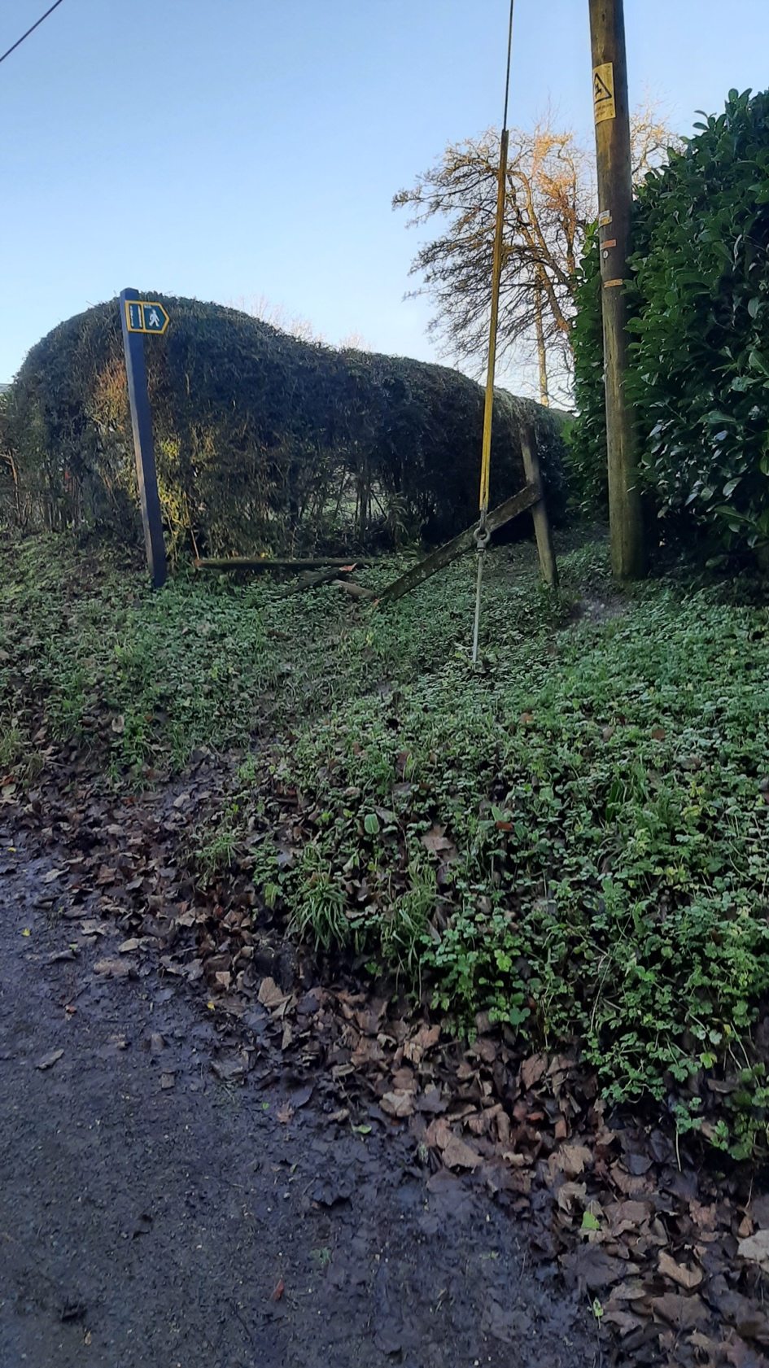

Good unchanged
Chute 15(footpath/permissive footpath).The footpath is clear .
Two new stiles with waymakers are in place either end of Standen farmhouse.

Moderate unchanged
Chute 16(footpath).The footpath is clear .There is no waymarker. The land owner has turned down the request to place a waymarker .

Poor down from good
Chute17 (footpath) from the corner of Wither’s field the footpath is clear.The nettles have died back at the start of the wooded area ,naturally improving the access.The wooded section of the path has a large tree blocking the the way causing a major reroute.This fallen tree has been raised previously at the parish council meeting .
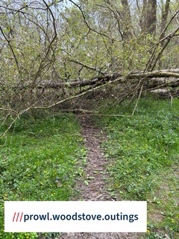

Good up from Poor
Chute 18(footpath).The stile at the Cross keys end as well as the fencing have been removed and the whole area has been cleared. Could a request be made to the land owner so that when a new fence is put in that a gate is used to replace the stile? The step on the stile entering the orchard has been replaced with an excellent stile ,a big thank you to the owner. The stile at the other end of the orchard has a high step to exit the orchard .Could the owner be contacted to ask for a further step to be added .The rest of the pathway is clear .
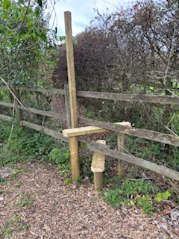

Good unchanged
Chute 20 (footpath) is clear.

Moderate unchanged
Chute 21(bridleway)is becoming overgrown and narrow but useable, it would benefit from being mowed before new growth appears.

Good unchanged
Chute 25(bridleway) is clear.

Good unchanged
Chute 26(footpath) is clear.

Good up from Poor
Chute 28(footpath).The footpath is clear.

Good unchanged
Chute 30(footpath/bridleway).Both are clear.

Good unchanged
Chute 31(bridleway) is clear .

Good unchanged
Chute 32(restricted byway)is clear

Good unchanged
Chute 33(bridleway) is clear .

Moderate unchanged
Chute 34 (byway) still has no waymarker at Mount Cowdown but is clear.

Good unchanged
Chute 35(byway) The byway is clear.The large boulders have been removed from white lane.

Good unchanged
Chute 36(restricted byway/bridleway) is clear.

Good unchanged
Chute 37 (bridleway) is clear.

Good unchanged
Chute 38(footpath) is clear ,although the path is narrowing in places due to brambles and would benefit from a cut back before new growth appears.

