MINUTES OF THE MEEETING OF CHUTE PARISH COUNCIL
HELD ON THURSDAY 4 APRIL 2024
AT CHUTE VILLAGE HALL

31/24 OPEN FORUM
9 members of the public were present.

Robin Hallam of Gammons Farm came to the meeting to request that the parish council support him over the retention of posts marking the edges of the by-way (BOAT) running between Scots Poor and Herridge Stud as the WCC Rights of Way officer says they are restricting highway access and should be removed. It can only be assumed that a complaint has been filed. The posts were erected long ago and have had a good effect with regards to preserving the verges. The track is approx. 3.5m wide. WCC RoW have supplied materials in the past but the maintenance work to the track has been carried out by the Hallam’s. The Forestry Commission are one of the main users of the track and have been very supportive by providing labour and materials to help with the upkeep. The posts help keep lorries on the track which is very well used by walkers, riders, pony and traps and cyclists. All neighbours have been consulted and nobody objects to the posts. Since the posts have been installed there have been fewer 4x4’s, campers and parking on the edge of the right of way, which is not allowed. The posts are sufficiently spaced so there is room for vehicles to pass.

Edward Novis says off-road bikes in the woods around Honey Bottom are still a problem and the police are not interested in taking action. Cllr Williams urged Edward Novis to continue to report incidents on the WCC website and recommended sending a letter to the Police & Crime Commissioner about the matter. It was further suggested that the registration numbers were sent to the British Off-Road Association.

Fiona Libby wanted to know what speeding restriction measures were being considered. PC Kaur has offered the services of the speeding team. The item was not on the meeting agenda but has been over the years with no satisfactory solutions found, although an article was sent to the Chronicle for publication this month.

David Brown said the children playing in Upper Chute are at risk due to the speed of the traffic. However, Chute has less problem with speeding than most parishes. It should be a priority for the road markings and speed limit signs to remain clean and visible. Most of our roads are single carriageway and outside the speed limit areas they have a 60mph limit. Residents and delivery drivers are the main offenders.

The parish council had a site meeting on 2 April with the new owner of the Old Vicarage and Stuart Collins of GreenTips, who is the tree surgeon, and everybody present was very impressed by his knowledge and happy with his recommendations regarding tree works. David Brown has filed his own comments on the planning portal as he is the owner of a neighbouring property.

32/24 PRESENT
Cllr Wall (Chairman), Cllr Parr (Vice-Chairman), Cllr Hopton, Cllr Harker, Cllr Taylor, Cllr Alderson and Cllr Rudland were present. Cllr Williams (WCC) was present. The Clerk was in attendance.

33/24 APOLOGIES
There were no apologies.

34/24 DECLARATIONS OF INTEREST
There were no declarations of interest.

35/24 MINUTES OF THE LAST MEETING
The minutes of the last meeting held on 7 March 2024 were proposed by Cllr Hopton and seconded by Cllr Harker. The minutes were then signed by the Chairman as a true record. The Clerk asked if the minutes could be more concise in future. They are not a verbatim report but a record of how decisions are made how expenditure is approved. It was agreed to try and keep the minutes shorter in future.

36/24 PLANNING
PL/2024/02281 Conholt Park – 4th phase landscaping including ha-ha, lake, tree planting - Support
PL/2024/02347 Conhholt Park – Variation of Condition 5 re. PL/2023/04076 - Support
PL/2024/01724 The Old Vicarage, Upper Chute – Tree works/removal of shrubbery - Support
PL/2024/02641 Longview, Malthouse Lane – Conifer crown reduction to clear cables – Support

37/24 COUNTY COUNCILLORS/WILTSHIRE POLICE REPORTS
Cllr Williams submitted his report to The Clerk prior to the meeting and it is attached to the minutes.
PCSO Rhupinder Kaur did not attend the meeting but sent in a report which is attached to these minutes.

38/24 PARISH REPORTS
Highways (TH)
The gully map is now uploaded onto the parish website. Cllr Harker thanked Huw Lovesey for helping to clear the trees debris from the roadside in Upper Chute where the Laburnum fell. The parish steward has dealt with the various issues concerning signs. The repainting of white lines in the parish is on a waiting list with the team who undertaken this work for WCC so we will have to be patient.
Footpaths (AR/MA)
Cllr Rudland said she would liaise with Carys Hughes at WCC RoW about the Gammons Farm track matter. Cllr Wall reiterated that enforcing restrictions on a right of way designated as a BOAT (Byway Open to All Traffic) was extremely difficult without police support.

Cllr Rudland said that it has been too wet for the landowner to repair the broken stile on Chut17. It has been reported that the stile on Chut9 below Crystal Palace Farm is broken. The landowner will be asked to repair it.

King George Playing Field
Cllr Wall said that the new floor is in the pavillion and it has had 8 hours of professional cleaning. An electrician is needed as one of the heaters blows the trip switch and there is no power to the hand dryer. Southern Groundcare have not been back out as it has been too wet. The rubbish around the container needs to be removed by a scrap metal dealer and some of the other rubbish could be burnt.

Village Hall (CW)
Cllr Wall reported that the chimney work has been done but some of the window casements are rotten. She has received a quote for £8,500. The VAT cannot be reclaimed by the VHC. Other quotes will be obtained and an application to the lottery fund has been made. It has been decided to only do the worst window first. The William the Butler lunch was a success and the coffee mornings continue to be popular.

Allotments (MT)
Cllr Taylor said the annual rent bills need to be sent out by The Clerk during April.
Village Design Guide (MH)
Cllr Hopton said that 12 copies of the VDG are being printed, the cost of which will be shared evenly with Chute Forest PC. The Clerk will check with The Clerk to CFPC to see if the VDG has been uploaded onto their website. The planning consideration checklist has been uploaded as a standalone document onto the Chute website for ease of access.

39/24 FINANCE
Chute Parish Council has received a CIL payment of £3,131.51from Conholt Estate and a discussion was had as to what this money could be spent on when considering the CIL guidance notes. Village signposts were one suggestion. 3 wooden fingers posts from Acorn would cost @ £475. The large sign at the entrance to Upper Chute at the top of Butts Hill has no visible picture on it. It was suggested that a sign survey should be undertaken. Signposts to the Cross Keys need to be removed. CIL money could be spent on the village hall as it is a community venue. The AED at St Nicholas Church needs a new battery and a new heated cabinet.

The bank reconciliation and the corresponding bank statement for March were circulated to all councillors prior to the meeting. Parish Council funds were £8,958.37 reconciled to the March statement. The Chairman signed the bank reconciliation as a true record.

The record of payments made and received since the last meeting is as follows:

Payments Made:
27/03/2024 Clerks Salary – March £ 238.51
27/03/2024 HMRC – PAYE £ 59.58
Payments Received:
None
Payments for approval via online banking:
27/04/2024 Clerks Salary – April £ 238.51
27/04/2024 HMRC – PAYE £ 59.58

The above payments were then proposed by Cllr Wall and seconded by Cllr Anderson.
The Internal Audit has been booked with John Murray for 13 May 24. The External Audit is with PKF Littlejohn LLP, although we will be eligible for exemption.

40/24 CORRESPONDENCE AND ADMINISTRATION
Cadley well head works are near completion but work to refurbish the pond in Chute Cadley has been stopped as a great crested newt was found in the digger bucket. We now need to engage with the Conholt ecologist and acquire an A14 mitigation licence from Natural England before any further work can be undertaken.

The land at the top of Forest Lane, Upper Chute where the laburnum tree fell is eligible to be registered with WCC as Local Green Space as it satisfies all the criteria. The Clerk will progress this.

The meeting closed at 9.16pm.

The next Meeting of Chute Parish Council will take place on
Thursday, 2 May 2024 at 7.30pm in the Village Hall

Wiltshire Councillor Report April 2024
I have been to various meetings since the last PC meeting, the most notable being the Environment Select Committee – 20th March 2024. On the agenda of this meeting were several reports which were interesting.

- Libraries Development update - Wiltshire Council has 30 libraries across the county. They are all registered as Warm Spaces and staff have been trained to help people with energy queries. 683 Warm Packs were given out over the winter, containing hot water bottle, fleece throw, hat, scarf, and gloves. Radiator reflector panels and heated throws were offered to those in most need.
- From Apr 2023 to Feb 2024 5,367 low/no cost events and activities, attended by over 104,000 adults and children.
- Successful Partnership project with Public Health to loan blood pressure monitors and activity tracker watches in 4 libraries is being extended to 8 more.
- Provision of Reading Well self-help titles supporting those with long term health conditions, dementia, and mental health issues to find out ways to improve their health and wellbeing.
- From 1st April Libraries will be acting as community spokes for the new Family Hub model, hosting Health Visitor led baby checks, Breastfeeding Support Groups.
- Library staff are receiving 5 to Thrive trauma informed training to provide signposting to the Spurgeon’s led Family Hub provision.
- Best Start in Life – year-round reading scheme launched in Autumn 2023 provides encouragement to read and educational benefits for those 4-16. Also Multiply program (helping with Maths) in Libraries.
- Leisure Service Update – Wiltshire Council has 20 Leisure Centres. Overall growth of 31% in core membership types. This is from 15,644 to 20,420 memberships. Growth in fitness memberships has accounted for 33%, in swimming membership 21%.
- Four sites opened on August Bank Holiday 2023 – in total 1115 customers attended the facilities – mixture of member and non-member attendance.
- The trial will continue for the full year, excluding Christmas holidays.
- Update on Development of the MyWilts Pothole reporting functionality.
- Highways Annual Review of Service 2023
- Highway Network is the largest of the Council’s public assets with a replacement value of over £5billion.
- Highway Network of over 2,800 roads,3.9million square meters of footways, 1,000 highway bridges and approximately 50,000 streetlights, illuminated signs and bollards and over 200 traffic signal-controlled crossings and junctions
- During 2023 the highways service has:
  - Resurfaced 32km of road and 2.4km of footway
  - Retextured 9km of road to improve skid resistance.
  - Surface dressed 63m of road.
  - Filled 14,891 potholes.
  - Carried out 600 bridge inspections.
  - Delivered over 180 local schemes through LHFIG.
Council Tax statements have been sent out showing that the council has raised the council tax for 2024/25 by 4.99% (which includes the adult social care levy), together with a letter from the Leader of Wiltshire Council, Cllr Richard Clewer, which gives a breakdown on how every £100 of core funding is used.
Tidworth Area Board met on Monday 18 March and received a presentation on Highways and Transport matters which included the following topics:
- Strategic Business Plan
- Maintenance
- Local Transport Plan
- Congestion
- Public Transport
- Air Quality.
This was followed by a question and answer session and the meeting concluded with partnership reports and the final award of community grants for this Financial Year which included a grant for the installation of a Hive smart thermostat for Chute Village Hall.




EL12 Ludgershall and Rural Police Report – March 2024

- Inspector 1619 Ricky LEE
- Sergeant 2687 Caroline RALPH
- Police Constable 2054 Jody KINGE
- Police Community Support Officer 6373 Rupinder KAUR

Pro-Active Work

- Johnson way, Ludgershall- ASB has been reported in area, enquiries are still on going. Patrols being conducted.
- Shears Inn, Collingbourne Ducis- Unknown suspects have gained entry to a locked storage unit and have stolen 7x 20 litres of cooking oil; value of £200.00. Enquiries are still ongoing. Patrol being conducted.
- The Barleycorn, Collingbourne Kingston- Unknown suspects have gained entry to a locked storage unit and have stolen used cooking oil. Patrol being conducted.
- Ludgershall Centre- Female found in possession of cannabis. Targeted Patrols are being continued.
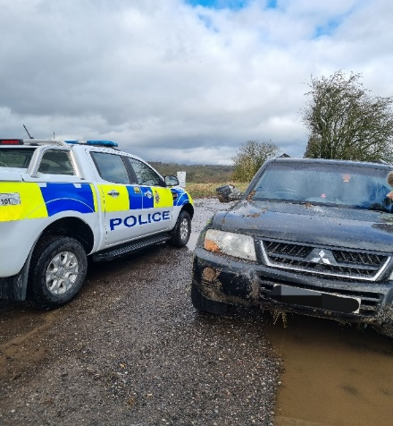
- Merrington Garden, Ludgershall- Continued ASB reported in the area. Patrols being conducted.
- Castle street, Ludgershall- Burglary by known female has entered the property and taken a wallet containing £200. Same female has then returned the wallet asking for a reward. Female has been then arrested and charged for burglary dwelling, public order and other offences; patrols being conducted
- Salisbury Plain, Everleigh- Abandon vehicle has been reported on the plain, believed to be used for hare coursing. Patrols being conducted in the area.

- Collingbourne Ducis-Unknown suspect has cut the padlock on reporting person’s lorry and stolen a junior quadbike. Enquiries are going.

- Salisbury Plain near Fittleton- Reporting Person was on a walk, his vehicle window has been smashed and his items have been stolen. Enquiries are still ongoing.

- Op Scorpion- Weapon sweeps have been completed in different areas including play parks and open areas in Ludgershall, Collingbourne Ducis, Kingston, Netheravon, Chute, Enford, Everleigh and Durrington Avon Valley school.

- Assisted response officer with a road closure in Collingbourne Ducis for serious RTC injury between Collingbourne Kingston and Burbage.
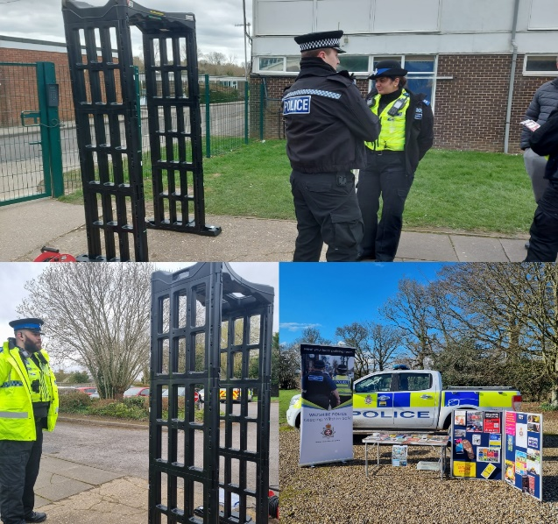
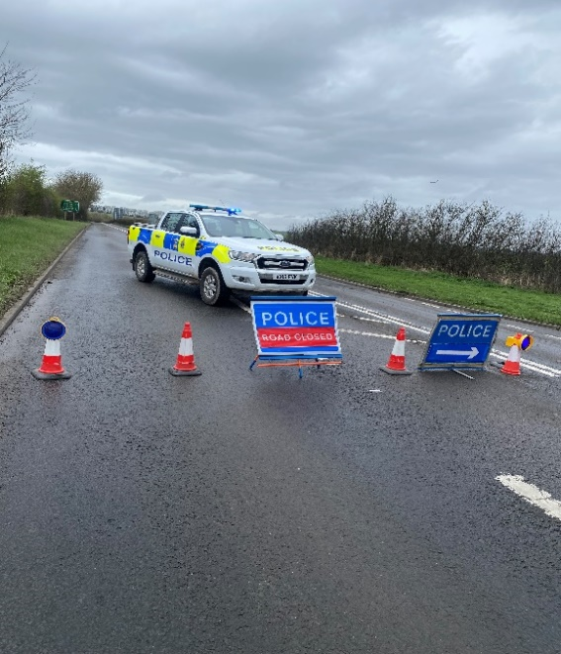

Community Speedwatch
Ludgershall (Tidworth Road)-
This stretch of road has a clearly displayed speed limit of 30mph. Perhaps because the roads were reasonably empty on this occasion, there was an increased temptation to ignore the posted limit. As a result, the fastest vehicle was captured travelling at 50mph.
Depending on previous convictions and history: -
5 drivers will be offered a speed awareness course
1 driver will be subject to court recovery.
Collingbourne Kingstone (Cuckoo Pen Railings)
This stretch of road has a clearly displayed speed limit of 30mph. The fastest vehicles were captured travelling at 39mph.
Depending on previous convictions and history all 5 drivers will be offered a speed awareness course.
Enford near bus stop
This stretch of road has a clearly displayed speed limit of 30mph. The fastest vehicle was captured travelling at 41mph. On the day in question, it was damp.
Depending on previous convictions and history: -
4 drivers will be offered a speed awareness course.
Proceedings will now be undertaken to ensure the most appropriate outcome for the offenders takes place.
Community Engagement
- PCSO, along with the early intervention team, attended the Wellington Eagle School in Ludgershall to deliver school talks about ‘Safer Choices’ to Year 6.
- Op Scorpion: Weapon sweeps have been done in different areas: play parks Ludgershall, Collingbourne Ducis, Kingston, Netheravon, Chute, Enford, Everleigh, and Durrington; engaging with the local community
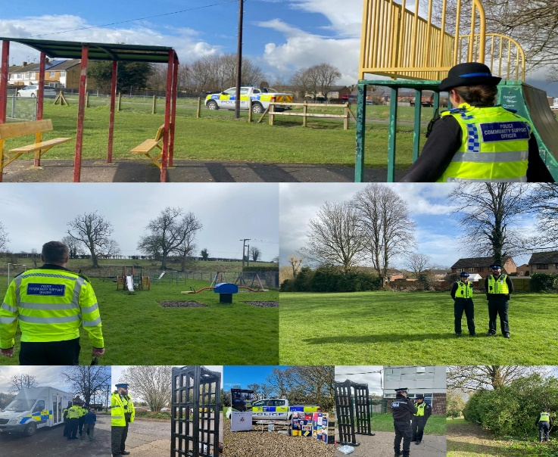

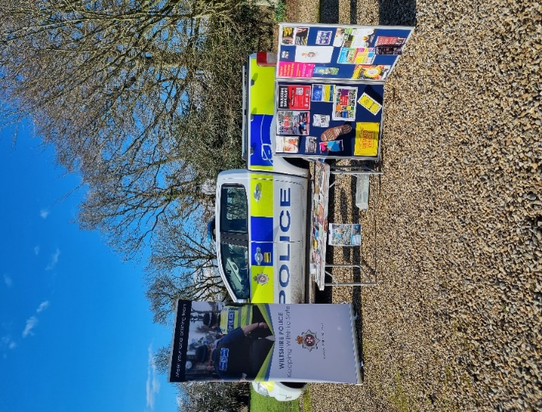
- Local PCSO and PC attended coffee mornings in Netheravon and engaged with the local community in Netheravon.
- The local PCSO attended the coffee mornings in Ludgershall and engaged with the local community.
- The local PC and PCSO attended Enford Farm. Enford, West Hill Farm Everleigh, and Southgrave Farm Collingbourne Kingston engaged with farmers and heard their concern about hare coursing poaching.
- The local PCSO and PC attended the Netheravon primary school to deliver the talk about ‘people who keep us safe’ to reception and Year 1.
- The local PCSO and PC held the community consultation in Chute village hall.

OP RECALL
We want to take the time to pass some important messages regarding livestock worrying and what you can do to stop it from happening:
• Keep dogs on a short lead when around livestock.
• Clear up after your dog as faeces can harm cattle and sheep – and humans too!
• Remember your actions can affect other people's lives and livelihoods.
• Tampering with farm signs and electric fences that are intended to everybody keep safe could have serious consequences.
• Please do not remove signs that are there to keep people safe and always leave gates how you found them - or follow instructions on signs on gates.
• If you see a dog or dogs chasing livestock please call 999 and provide as much information as possible.
• Photo or video evidence of any dogs may help if you can do so safely.


Priority Patrols
- Ongoing reassurance patrols around Upper Chute and Chute area for following the ASB and Nuisance reports.
- Regular reassurance patrol of Collingbourne Ducis, for following the report of burglaries.
- Regular reassurance patrols of Merrington Garden, Ludgershall for following a report of ASB.
- Regular reassurance patrols of Johnson Way, Ludgershall for following a report of ASB.
- Regular marked vehicle patrols targeting Rural Crime, Poaching, Fuel theft, Hare Coursing in Enford farm, Colingbourne Ducis Farms, Collingborne Kingston Southgrave farm,West Hill farm in Everleigh, Nertheravon Haxton farm.

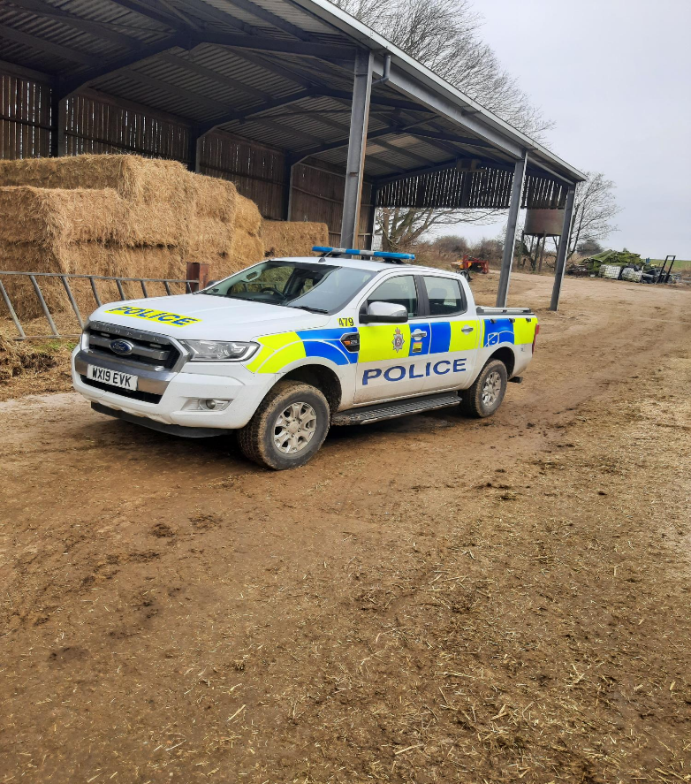

Numerous other activities have been carried out, which cannot be disclosed for operational reasons

Reporting Incidents or Intelligence

At Wiltshire Police, we have a number of ways you can report crime or incidents

- Via our online reporting hub https://www.wiltshire.police.uk/ro/report/
- Via 101 for non-emergencies and the drink drive hotline.
- Via 999 for crimes in progress and immediate threats or danger
- Via the Amesbury email inbox AmesburyAreaCPT@wiltshire.police.uk
- Directly to your Neighbourhood Policing Team via email

amesburyareanpt@wiltshire.police.uk

You can also view a crime and incident map for your area; this will show you crimes and incidents that have been reported https://www.police.uk/pu/your-area/wiltshire-police/amesbury/

