MINUTES OF THE MEEETING OF CHUTE PARISH COUNCIL
HELD ON THURSDAY 7TH NOVEMBER 2024
AT CHUTE VILLAGE HALL

95/24 OPEN FORUM
3 members of the public were present.

Huw Lovesey reminded Cllr Wall that he had requested a laminated footpath map for display on the notice board in Upper Chute. Cllr Wall will supply this. Huw also noted that the small grass triangle at Chute Standen has been fenced off and re-seeded. Thank you to the Parr’s for doing this.

96/24 PRESENT
Cllr Wall (Chairman), Cllr Harker, Cllr Alderson and Cllr Rudland. Cllr Williams (WCC) was also present. The Clerk was in attendance.

97/24 APOLOGIES
There were apologies from Cllr Parr (Vice-Chairman) and Cllr Hopton. Cllr Taylor did not attend the meeting.

98/24 DECLARATIONS OF INTEREST
Cllr Alderson Tree Works 1 Chute Cadley

99/24 MINUTES OF THE LAST MEETING
The minutes of the last meeting held on 3rd October 2024 were proposed by Cllr Harker and seconded by Cllr Rudland. The minutes were then signed by the Chairman as a true record.

100/24 PLANNING
PL/2024/09287 Fosgate House, Upper Chute – Treeworks re. Cherry/Ash - Support
TPO Tree Works – 1 Chute Cadley – Fell Rowan Mountain Ash and Silver Birch - Support

101/24 COUNTY COUNCILLORS/WILTSHIRE POLICE REPORTS
Cllr Williams submitted a written report to the Clerk prior to the meeting and this is attached to these minutes.

The local police report by our PCSO’s was submitted prior to the meeting which was circulated to councillors and is also attached to these minutes.

102/24 PARISH REPORTS
Highways (TH)
Cllr Harker said that the priority gullies in Lower Chute, Upper Chute and Cadley Bottom have been agreed.
The resurfacing of Hookwood Lane is due to go ahead imminently and signs advising of the road closure are already in place.
Fin Guinness has not responded regarding help to install the new signpost at the end of Hookwood Lane so Richard Gregory will be asked if he could help remove the old post and Cllr Harker and Huw Lovesey have confirmed that they will install the new one.
Gammons Farm Track – Robin Hallam sent an e-mail updating the parish council on his proposal to WCC Highways, in conjunction with the Forestry Commission, about a compromise regarding the boulders and posts on the track. He has also proposed installing a dedicated parking area for walkers to use. He has the full support of the parish council and Cllr Williams, and he has agreed to copy all parties in on any developments.
Footpaths/Rights of Way (AR/MA)
Chute 9 – The stile is on the ground at one end. Cllr Rudland will ask Fin Guinness/Martin Tobutt if they are prepared to replace the stile. The stile is on the boundary between the Sykes and Guinness’s land.

Chute 15 – The height of the stile railing was reduced by removing the top rail and Cllr Hopton confirmed at the October meeting that step will be added to reduce the step up and down on the Chute Standen side, but this has not yet been done.
It has been observed that new footpath signs have been erected on Conholt Estate footpaths stating that dogs should be on leads at all times. It is not law to have your dog on a lead on a footpath in the UK, but they do need to be under strict control.

King George Playing Field (CW/TH)
Cllr Wall reported that activity on the playing field is very quiet. The rubbish behind the container still needs to be removed and the scrap man has advised that he is waiting for a new truck before he can do the job.

The recent ROSPA inspection states that the seesaw is not fit for purpose, so it is currently taped off. Eddie Quirke, who originally built the seesaw, has agreed to repair it.

Village Hall (CW)
Cllr Wall reported that an assessor for the insurance company has carried out a valuation for re-build purposes and provided a valuation of £1.6m. This has put the insurance premium up by £500 p.a.

The hall is currently very quiet for bookings. The clothing recycling bin has been removed by the Air Ambulance as duvets and pillows were stuffed into it.

Allotments (MT)
The Clerk met Cllr Taylor and Cllr Harker at the allotment site on Saturday, 5 October and Cllr Harker kindly drew up a new allotment plan showing only useable plots. The plot holders who have not tended their plots for a while have been asked if they wish to surrender them so that they can be allocated to other parishioners. Once the situation has been clarified the available plots will be advertised in The Chute Chronicle.
103/24 FINANCE
The draft budget was circulated to all councillors prior to the meeting for review. It will be agreed at the January meeting by full council. There are two additions. The bank has advised that we will be subject to charges of £50 p.a. in future and we are awaiting a grass cutting quote for the playing field and all the Upper Chute greens. The war memorial in Lower Chute, which is jointly owned with Chute Forest Parish Council, might need some maintenance. It was discussed that the precept should be increased from £9,000 to £9,300, which is only a 3.3% increase. We are awaiting the precept request form from WCC and will finalise/agree the budget in January.
The Clerk’s pay was reviewed as there has been no increase for two years and will go up from £13.78 per hour to £15 per hour for 5 hours a week. This was approved by all Councillors present at the meeting and will take immediate effect.

The bank reconciliation and the corresponding bank statement for October was circulated to all councillors prior to the meeting. Parish Council funds were £8,856.18 with £6, 071.90 in the current account and £2,784.28 in the deposit account and these figures reconciled to the bank statement. The Chairman signed the bank reconciliation as a true record.

The record of payments made and received since the last meeting is as follows:

Payments Made:
11/10/2024 ICO Subscription £ 35.00
21/10/2024 WelMedical – new AED Cabinet for church £ 635.94
27/10/2024 Clerks Salary – October £ 238.51
27/10/2024 HMRC – PAYE £ 59.58
Payments Received:
14/10/2024 TFR of CIL funds re. fingerpost £630.00
31/10/2024 VAT Refund £198.28
Payments for approval via online banking:
08/11/2024 The Royal British Legion Poppy Appeal £ 40.00
27/11/2024 Clerks Salary – November £238.51
27/11/2024 HMRC – PAYE £ 59.58
The above payments were proposed by Cllr Wall and seconded by Cllr Harker.
104/84 PARISH IMPROVEMENT PROGRAMME
Area at the top of Butts Hill. It has now been confirmed that the small area of land where the water gathers in a natural soakaway is unclaimed land. The roadside verges belong to WCC and the Sanctuary Housing boundary is where their fence has been erected. It was agreed that the land should be registered to the Parish Council. Cllr Rudland has offered to look into how this land can be registered in the name of the parish as it does not fit the criteria for a village green.

Further to the last meeting where discussion took place about the landscaping of the land at the top of Butts Hill, Cllr Hopton had suggested asking a landscape designer to produce two schemes which we could then ask the parish to choose between. The area needs to be low maintenance. Cllr Wall will speak to the ecologist we used for the pond in Chute Cadley for ideas.

Cllr Wall advised she had received several requests about planting daffodils around the parish. Cllr Harker said that it may be a bit late for this year but it should be something we consider in good time for next year.

Cllr Wall has obtained two quotes to pollard the Lime tree on Chute Cadley Green. Both tree surgeons recommended leaving the two Silver Birches as they are. A third quote is being sort. The Chestnut tree in Upper Chute has a bit of die back but is otherwise healthy.

A replacement defibrillator cabinet has been bought for Upper Chute Church as the electrics burnt out in the old one. Cllr Wall will find out if we can apply for a 50% grant towards the cost from the Tidworth Area Board.
105/24 CORRESPONDENCE AND ADMINISTRATION
It was discussed whether we wanted at the current time to change our e-mail provision from one.com with a .co.uk suffix to Hugo Fox to get a .gov.uk suffix. It has not been suggested that we are currently required to make this change and the switch would be disruptive. It would also cost more to switch our e-mail provision to Hugo Fox, so it was decided to leave things as they are for now.

The meeting closed at 8.30 pm.

The next meeting of Chute Parish Council will take place on
Thursday, 2nd January 2025 at 7.30pm in the Village Hall

Wiltshire Councillor Report October/November 2024

Full Council meeting took place on Tuesday 15 October.
Items on the agenda included the Wiltshire Local Plan Review – Submission of the Draft Plan. Approval was given by Council to submit the draft Local Plan to the Secretary of State for approval. This follows on from statutory (Reg 19) consultation which took place at the ends of 2023. This new Local Plan will help meet the council’s legal requirements to have an up-to-date Local Plan in place.
An updated Enforcement Policy was endorsed, the aim of which is to reinforce a “one council” approach to enforcement across Wiltshire Council.
There were Statements of both Licensing Policy and Gambling Principles, and various members’ motions were debated, including one on Winter Fuel Payments, requesting the Leader of the Council write to the Chancellor of the Exchequer, Rachel Reeves MP, urging a review of Labour’s decision to end the Winter Fuel Payment and after a lengthy debate on whether to accept amendments or not, the motion was approved with no amendments Private Motor Vehicles – the motion was passed, again with no amendments, that the Council refuses to support any scheme that seeks to force people out of their cars without a high quality, efficient, reliable and cost-effective alternative in place. There is a lot more information on the Council website regarding these and other subjects that were discussed on the day.
Tidworth AB met on Monday 7 October, there were various partner updates, the main one from Wiltshire and Swindon Road Safety Partnership. Grants were approved for repairs of the St James Church Bells, and winter maintenance of the green at Castledown Bowls club. Castle Practice also made a request for a grant towards a carer’s café being set up and Dollys Tea Rooms. Though local members support this application, it will have to go to a Criteria Panel for a final approval. There was also a verbal report from the LHFIG with any decisions from this meeting being approved at the next AB meeting in December as there was not a full weeks’ notice to have them on the agenda.
The next AB meeting takes place on Monday 9 December at Ludgershall Memorial Hall.

Christopher Williams
Wiltshire Councillor for Ludgershall North and Rural
Tel: 07712159562 Email: christopher.williams@wiltshire.gov.uk




EL12 Ludgershall and Rural Police Report – September 2024

- Inspector 1619 Ricky LEE
- Sergeant 2687 Caroline RALPH
- Police Constable 2054 Jody KINGE
- Police Community Support Officer 6373 Rupinder KAUR

Pro-Active Work

- Tidworth Road, Ludgershall – Traffic officer seized a vehicle for no insurance S165.

- West Hill Farm, Everleigh and Collingbourne Ducis- Vehicle with three male occupants spotted hare coursing on farmland. Vehicle has failed to stop for officers. Occupants have decamped but located by officers. All three arrested on suspicion of hare coursing and driving offences including dangerous driving failing to stop, driving without insurance also without the valid MOT. Patrols being conducted
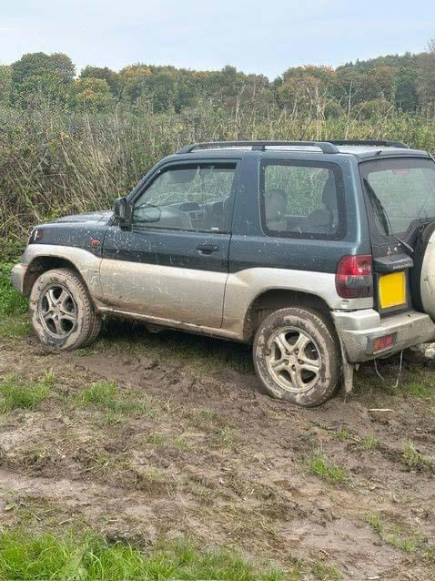

- The Sidings, Ludgershall- Unknown youths are regularly riding their bikes and running over the reporting person’s grass and throwing balls at resident’s cars. Patrol being conducted.

- OP Scorpion- During the OP Scorpion last month we target the following:-
  - Overweight Lorries/ Speeding, Ludgershall – Contact has been made to companies with clear CCTV about Overweight Lorries are not allowed on high street also local officer spoke to few lorry drivers about overweight lorries are not allowed. Patrol being conducted.
  - Speed check on Andover- numerous vehicles been stopped for no insurance, no MOT and excess speeding also vehicle been seized for speeding, no insurance, no MOT, TWOC.
  - Leaflets drop- Leaflets been dropped to leisure centres, school, libraries/ Cuckooing address checks done.
  - Drink and drug traffic OP- 28 vehicle been stopped and spoken about FATAL 5 also few vehicles been seized for no insurance, no MOT, No Licence etc

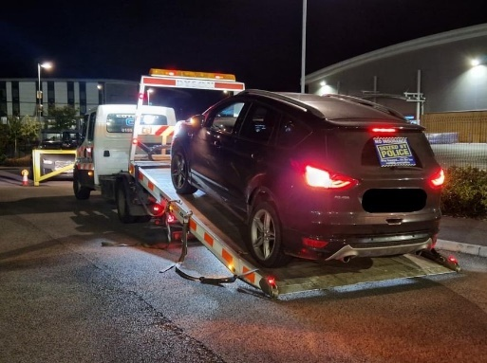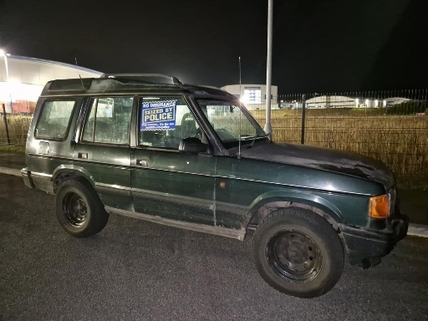
- OP SELL- There has been numerous Van breaking in Wiltshire and out of the force areas, Local officer is assisting with witness statements, H2H enquiries also DNA kit given to injured people. Enquiries are still ongoing. Patrols being Conducted.
- 

- Enford farm, Enford- Unknown- Numerous time unknown persons have been using dogs and lamps on the field, believed for hare coursers/poachers. Patrols being conducted.
- Spray Leaze, Ludgershall- Unknown suspect(s) has thrown stones/rocks at the window causing damage/smashing property enquiries are still ongoing. Local officer has done the ASB surveys also put the Tab slide for foot patrol.
- 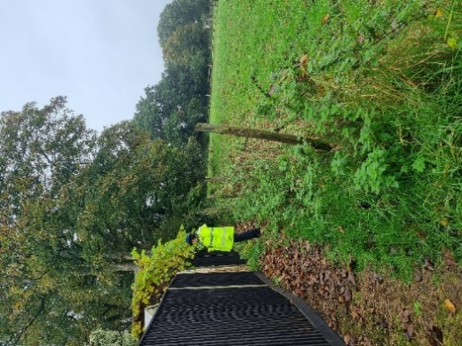

- Netheravon- 2 x vehicles with high powered lamps were sighted with whippet type dogs running, believed to involve in hare coursing. Patrol being conducted
- COLLINGBOURNE DUCIS- Unknown group of youth has thrown a brick or rock at the reporting person’s vehicle as he was driving along. This has caused the windscreen to smash in the bottom right-hand corner., also being loud and causing ASB for residents. Enquiries are still ongoing. Patrol being conducted.
- Rural Operation Crime Week: -Recent reports with concerns from members of public about hare coursing on the farms around Ludgershall and surrounding areas. Local Neighbourhood team patrolled last month and have attended farms in Chute, Everleigh, Collingbourne Kingston, Collingbourne Ducis, Netheravon, Enford engaged with farmers and crime prevention advice has been given to farmers.
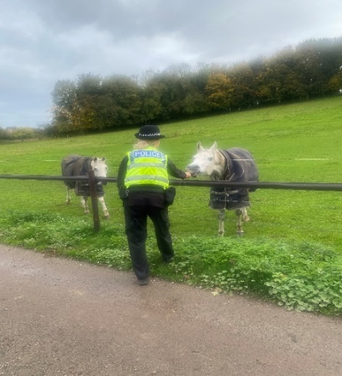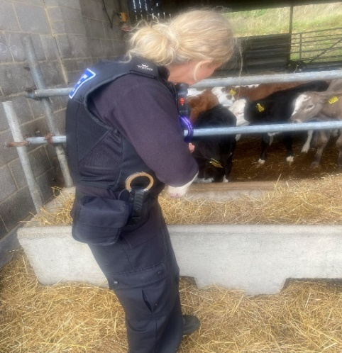
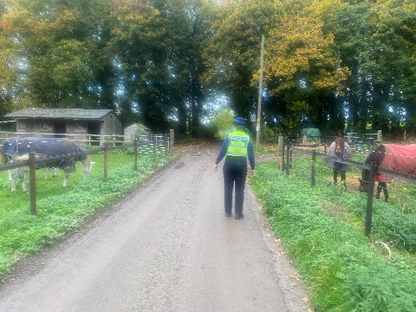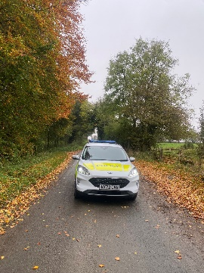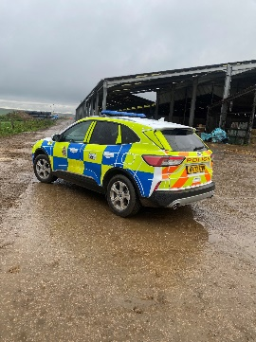
- Collingbourne Woods, Ludgershall- Unknown suspect has stolen reporting person’s Doberman whilst she was out walking her dogs in the woods. Enquiries are still ongoing. Patrol being conducted.
- Everleigh- Unknown suspect has smash the rear window of the parked car. Suspect has then lifted the parcel Helfand has stolen the rucksack from the boot of the car. Enquiries are still ongoing, patrol being conducted.
- Business Crime Action week between 14th-18th October- local NPT have attended the local retail premisses in Ludgershall, Colingbourne Ducis, Netheravon, shared intelligence, drop the leaflet about shoplifting also crime prevention advice has been given shopkeepers.

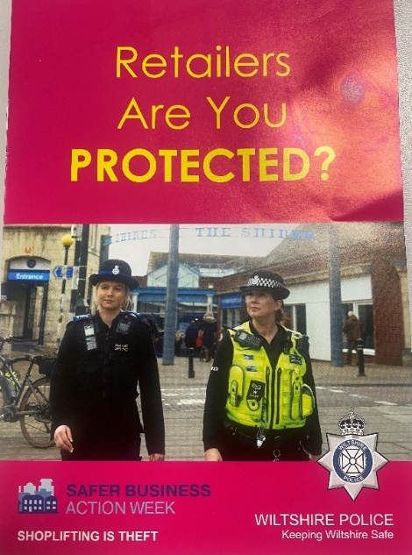

Community Engagement

- A high visibility foot patrol was conducted Ludgershall! Officers engaged with members of the public, assisting with enquiries, and gaining Intelligence.

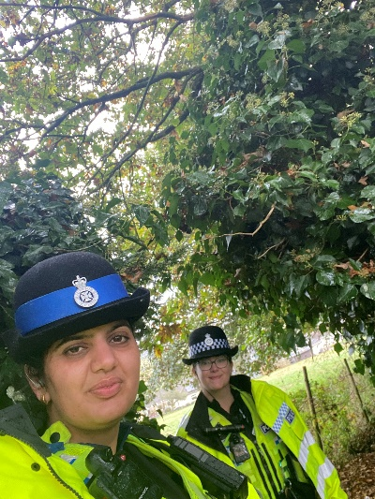
- PCSO KAUR and PCSO MORPHY have attended the Ludgershall town council to discuss the community issues also held the community consultation inside of Ludgershall town council and engaged with the local community.
- Attend the local shops in our area during Business crime week also done the foot patrol and engaged with them and gave the crime prevention advice.

- During Rural crime action week, I have attended 15 farms and engaged with them also offered the crime prevention advice.
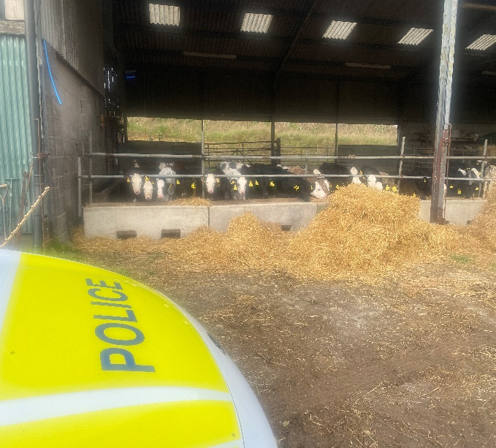

- NPT officers attended the Bonfire night in Enford, engaged with local Families also discussed with them the local issues.


Speed Enforcement

- COLLINGBOURNE KINGSTONE - 03 October and 24 October 2024 speed checks carried out in COLLINGBOURNE Kingston near the Cuckoo Pen.
- Speed Enforcement caught 11 vehicles speeding in total
- This stretch of road has a clearly displayed speed limit of 30mph. The fastest vehicle was captured travelling at 41mph. On the day in question, it was overcast, and roads were still damp in places. It was also very quiet, traffic-wise.
- Depending on previous convictions and history all four drivers will be offered a speed awareness course.
Proceedings will now be undertaken to ensure the most appropriate outcome for the offenders takes place.

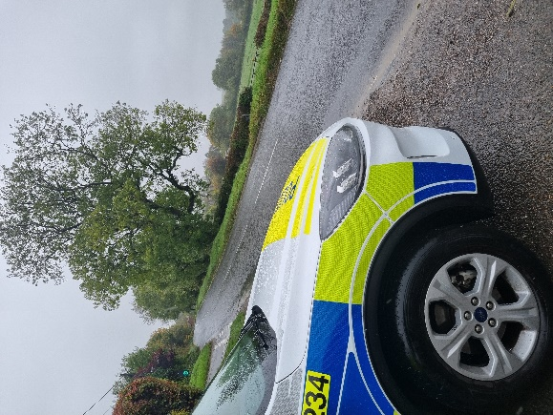
- Tidworth Road Ludgershall- 03 October and 24 October 2024 speed checks carried out in Ludgershall on the Tidworth Road.

- Speed Enforcement caught 37 vehicles speeding on total.
- This stretch of road has a clearly displayed speed limit of 30mph. The fastest vehicle was captured travelling at 43mph. On the day in question, it had brightened up but roads were still damp in places.
- Depending on previous convictions and history: -
35 drivers in total will be offered a speed awareness course
2 driver will receive a Fixed Penalty Notice and 3 points.
- Andover Road, Ludgershall- on 7 of October and 19/10/2024 October speed check carried out by PC KINGE and Special road safety Unit.
- vehicle report for no tax
- 3 traffic offence report for excess speed
- 1 traffic offence report for careless driving
- 2 traffic offence report for no insurance
- 1 vehicle reported for speeding, no insurance, driving otherwise than in accordance with license, no MOT , TWOC, vehicle Seized
- Proceedings will now be undertaken to ensure the most appropriate outcome for the offenders takes place, which includes checking for MOT, Insurance & Point Totters.
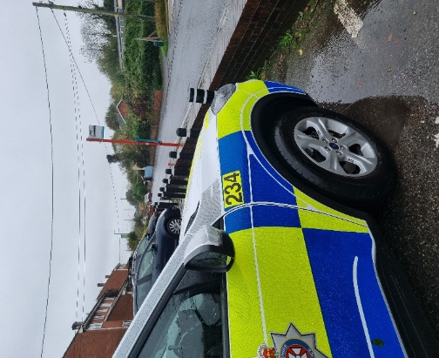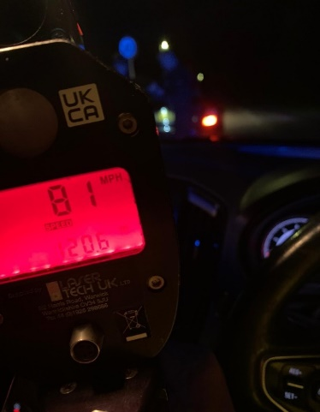

Netheravon A345- Speed Checks was carried out on 28/10/2024 15:00.
- No vehicle was speeding, all drivers were driving on the speed limit.
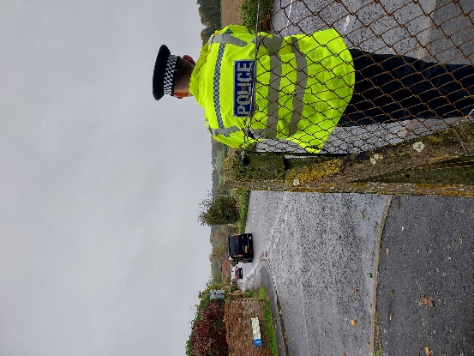
Collingbourne Ducis-03 October and 24 October 2024 speed checks carried out in COLLINGBOURNE DUCIS near the Everleigh Road.
Speed Enforcement caught 9 vehicles speeding in total.
This stretch of road has a clearly displayed speed limit of 30mph. The fastest vehicle was captured travelling at 46mph. On the day in question, it was brightening up, but overcast and roads were damp.
Depending on previous convictions and history: -
7 drivers will be offered a speed awareness course
2 driver will receive a Fixed Penalty Notice and 3 points.
Proceedings will now be undertaken to ensure the most appropriate outcome for the offenders takes place.
Priority Patrols

- Ongoing reassurance patrols around Upper Chute and Chute area for following the ASB and Nuisance reports.
- Regular reassurance foot patrols of Spray LEAZE, Abatt Close and surrounding areas of Ludgershall for following the report of Criminal Damage and ASB.
- Regular reassurance patrol of Collingbourne Ducis, Churchyard for following the report of Criminal Damage and ASB.
- The SIDINGs, Ludgershall - Regular reassurance patrol of the SIDINGS for following the report dirt bikes causing ASB.
- Ongoing reassurance patrol of Collingbourne Woods, Ludgershall for following the report of dog has been stolen.
- Regular marked vehicle patrols targeting Rural Crime, Poaching, Fuel theft, Hare Coursing in Enford farm, COLLINGBOURNE DUCIS Farms, COLLINGBOURNE KINGSTON farms, Everleigh farms, Netheravon and Haxton farm, Enford farm.

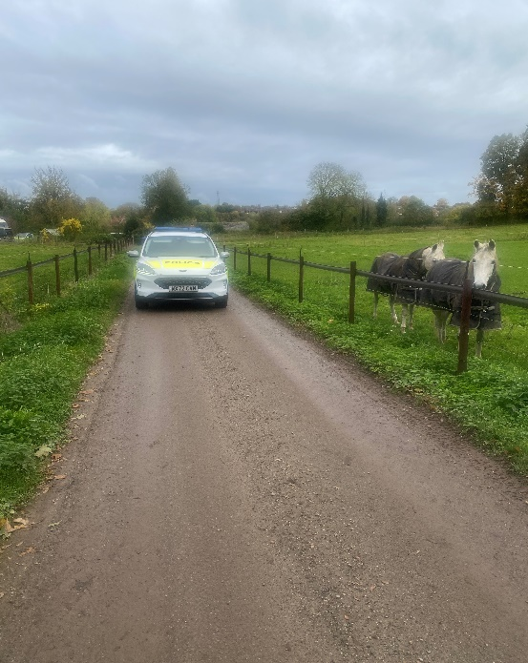

Numerous other activities have been carried out, which cannot be disclosed for operational reasons

Reporting Incidents or Intelligence

At Wiltshire Police, we have a number of ways you can report crime or incidents

- Via our online reporting hub https://www.wiltshire.police.uk/ro/report/
- Via 101 for non-emergencies and the drink drive hotline.
- Via 999 for crimes in progress and immediate threats or danger
- Via the Amesbury email inbox AmesburyAreaCPT@wiltshire.police.uk
- Directly to your Neighbourhood Policing Team via email

amesburyareanpt@wiltshire.police.uk

You can also view a crime and incident map for your area; this will show you crimes and incidents that have been reported https://www.police.uk/pu/your-area/wiltshire-police/amesbury/

