MINUTES OF THE MEEETING OF CHUTE PARISH COUNCIL
HELD ON THURSDAY 6TH FEBRUARY 2025
AT CHUTE VILLAGE HALL

12/25 OPEN FORUM
2 members of the public were present.

Mary Cummins asked if it would be possible to get WCC to install an additional streetlight by the bus shelter in Upper Chute as it is incredibly dark at night and the footpath into Tibbs Meadow is currently unlit. The Clerk will make the request to WCC.

Dummer Lane is narrow and there is no escape when on foot and a car approaches. The verges are muddy on both sides, and it is not safe for walkers. Mary Cummins asked if we could request that WCC deploy a road sweeper. Cllr Harker offered to report this and make the request on the MyWilts app.

Stephanie Godfrey-Davis said that girls are knocking on doors after dark in Tibbs Meadow and then running away. The parents should be asked by Sanctuary Housing to remind their children to be respectful to other residents and not to engage in threatening behaviour. The police have been involved and the Clerk will write to Sanctuary Housing asking them to remind their tenants of their responsibilities with regard to their tenancy.

13/25 PRESENT
Cllr Wall (Chairman), Cllr Harker, Cllr Hopton, Cllr Alderson, Cllr Taylor and Cllr Rudland. The Clerk was in attendance.

14/25 APOLOGIES
There were apologies from Cllr Parr (Vice-Chairman). Cllr Williams (WCC) and neither PCSO attended the meeting.

15/25 DECLARATIONS OF INTEREST
None.

16/25 MINUTES OF THE LAST MEETING
The minutes of the last meeting held on 2nd January 2025 were proposed by Cllr Harker and seconded by Cllr Hopton. The minutes were then signed by the Chairman as a true record.

17/25 PLANNING
No new planning applications received.
Cllr Wall advised that planning permission has been granted to replace the metal window frame at the VH.

18/25 COUNTY COUNCILLORS/WILTSHIRE POLICE REPORTS
Cllr Williams did not attend the meeting and had not submitted a written report to the Clerk.
Neither PCSO attended the meeting. No report was provided to the Clerk prior to the meeting.

19/25 PARISH REPORTS
Highways (TH)
Cllr Harker has reported the overgrown hedges on Hookwood Lane to WCC via the MyWilts app as the job is too big for the Parish Steward to undertake.The sharp edges of the newly resurfaced Hookwood Lane have been registered on the MyWilts app. Cllr Harker said a new gully service schedule had been sent out but the Clerk has not received it. The gully service is scheduled to attend 5 parishes in one week.
The 30mph sign is on the ground just beyond The Hatchet going towards Upper Chute.
The white lines in Upper Chute on the small crossroads have still not been reinstated and should have been done when the lines were repainted recently at the bottom of Hookwood Lane after it was resurfaced.

Trying to get WCC to add Conholt Hill to the gritting schedule has proved unsuccessful. A request has also been made by Vernham Dean Parish Council.

Grish Lohani of WCC Highways and RW Armstrong representatives, the main contractor working at Conholt Estate, met recently and a further meeting has been arranged on 17th February 2025.

Footpaths/Rights of Way (AR/MA)
Chute 9 – Cllr Rudland stated that Fin Guiness had explained that although the stile has not been replaced or repaired an alternative route has been opened up in the fence to the side of the stile allowing walkers to use the field edge on Sykes land, but this is not the official footpath so the matter still needs to be resolved.

Chute 17 – Cllr Taylor reported a fallen tree on the way to Limmer Ponds in the wooded area on Eccles land. Cllr Wall said she would speak to the owner.

Boulders outside Honey Bottom are blocking a byway open to all traffic (BOAT) and hedging has been planted on the verge opposite the curtilage of the property on the other side of the track, presumably with the permission of the landowner. There is now a gate at Ladies Lawn and signs saying ‘No Motorcycles’ have been there for some time, There are also large logs across the right of way which should be cleared as the foot gate adjacent to the log at Honey Bottom is broken, so there is no alternative but to climb over the log which may be hard for older people and riders who do not wish to jump it.

King George Playing Field (CW/TH)
Cllr Wall reported that the tree works proposed by SSEN on the playing field have been approved. The owners of Fox Barn have complained about the dead Ash trees and are worried that they may shed limbs or fall. This has been reported via the MyWilts app.

Southern Groundworks have been contacted to come and scarify the playing field.

Village Hall (CW)
Cllr Wall reported that the boiler has been serviced at a cost of £210. There is a leak behind the water softener as a pipe has broken which will incur a call out charge of £185.

Allotments (MT)
Following an article in the Chute Chronicle to advertise them as there has been some interest from two couples in taking on allotment plots. A site meeting was organised with Cllr Harker for midday on Saturday, 8th February to meet the new applicants and allocate the plots. Those surrendering their plots will be contacted again to advise of the outcome and ensure they are happy. SSEN tree works have been approved and all neighbours informed.
20/25 FINANCE
The Upper Chute grass cutting quote has been accepted and work will be undertaken fortnightly from April.

The bank reconciliation and the corresponding bank statement for January was circulated to all councillors prior to the meeting. Parish Council funds were £7,654.36 with £4,862.98 in the current account and £2,791.38 in the deposit account and these figures reconciled to the bank statement. The Chairman signed the bank reconciliation as a true record.

The record of payments made and received since the last meeting is as follows:

Payments Made:
27/01/2025 Clerks Salary – December £260.00
27/01/2025 HMRC – PAYE £ 65.00
27/01/2025 Hugo Fox Annual Subscription DD £143.86
Payments Received:
None
Payments for approval via online banking:
06/02/2025 Clerks Expenses – Ink Cartridges £ 35.18
17/02/2025 Domain name renewal £ 77.94
27/02/2025 Clerks Salary – February £260.00
27/02/2025 HMRC – PAYE £ 65.00
The above payments were proposed by Cllr Alderson and seconded by Cllr Harker.
21/25 PARISH IMPROVEMENT PROGRAMME
Area at the top of Butts Hill. Cllr Wall advised that the ‘pond’ has been shown to have been in existence on the 1836 map, has not been known to flood and drains completely dry in the summer month. Cllr Taylor updated that the pipe for emptying the sewage tanks has been left visible. It was agreed that this area should be re-seeded with grass and kept tidy/strimmed regularly and the area is included in the new grass cutting contract.

22/25 CORRESPONDENCE AND ADMINISTRATION
Cllr Rudland had looked at registering the land at the top of Butts Hill and had downloaded the forms to complete but had not continued due to a concern raised by another Cllr regarding liability. It was also suggested that it should be fenced but this is not practical. It was therefore agreed not to register the land.
The Clerk brought attention to a free charity called The Blue Lamp Trust which provides free security checks and the installation of basic safety equipment for the most vulnerable in any community. The information will be circulated via the village WhatsApp groups and the Hatchethill e-mail and uploaded onto the parish website.

The meeting closed at 8.32 pm.

The next meeting of Chute Parish Council will take place on
Thursday, 6th March 2025 at 7.30pm in the Village Hall





EL12 Ludgershall and Rural Police Report – December 2024

- Inspector1359 Gavin BREWSTER
- Sergeant 2687 Caroline RALPH
- Police Constable 2054 Jody KINGE
- Police Community Support Officer 6373 Rupinder KAUR

Pro-Active Work

- Coombe lane, Enford– Unknown suspects have attempted to open the sides of a garage door, however no entry gained, and nothing stolen. Enquiries are still ongoing. Patrols being conducted

- Ludgershall- Unknown suspect has stolen a parcel from doorstep. value of parcel £75.00. Enquiries are still ongoing. Patrol being conducted.

- Coombe Lane, Enford-Unknown suspect has gained entry to a van parked on a driveway and have stolen tools and copper approx. value £5000.Enquiries are still ongoing. Patrols being conducted

- Ludgershall- Unknown suspect caused scrape to driver's side door of the vehicle. Damage approx. value £220-230. Patrol being conducted

- Netheravon-Unknown male has carried out 5 transactions using fake Scottish £50 notes to the value of £800-£850. Patrol being conducted.

- Everleigh: - Unknown suspect(s) have smashed the passenger side window of the vehicle and have stolen Christmas presents £10 and various other items from the vehicle. Damage caused to vehicle approx. value £115.Enquiries are still ongoing. Patrols being conducted.

- Salisbury Plain: - Unknown suspect has set the fire of the vehicle parked on Salisbury Plain. Fire brigade extinguished fire but car a write off. Patrol being conducted

- Enford farm, Enford- Unknown- Numerous time unknown persons have been using dogs and lamps on the field, believed for hare coursers/poachers. Patrols being conducted.

- Highbury, Andover Road, Ludgershall: - Unknown company has arranged to do some guttering work for the reporting person. The company has come over the course of a few days but only completed knocking down her shed and doing some work to her patio which was not part of the agreement, the guttering did not get sorted. The males stated that she owed them £520 which she agreed to as she felt scared and wanted them gone. A verbal agreement was arranged for her to bank transfer this. Advice has been given to reporting person about rogue traders and scams Patrol being conducted

- CO-OP/ Tesco, Ludgershall: - Crime prevention advice has been given to COOP/ Tesco on recent scams about gift cards. Patrols being conducted.
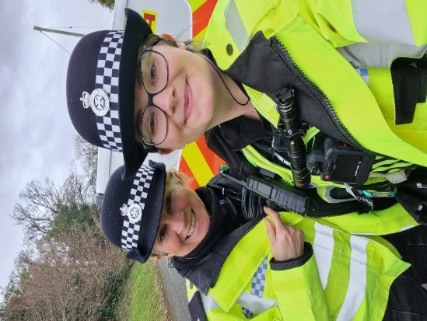
Community Engagement
- Local officers conducted the foot patrol and mobile patrol of the hotspot of ASB in Ludgershall, Larkhill, Collingbourne Ducis, Netheravon.

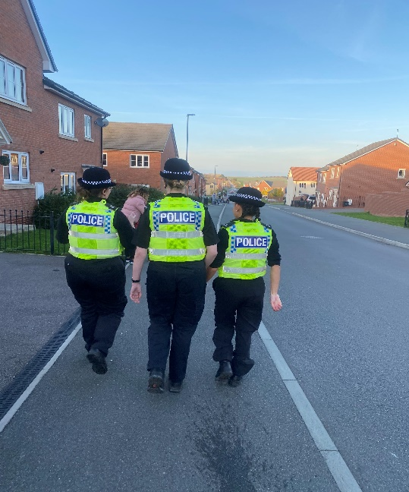

- Attended the CO-OP/ Tesco in Ludgershall to give advice about scams. Engaged with the staff and gathered intel.

- Local officer has done proactive patrols of farm, and engaged with farmer also gave the crime prevention advice to farmers.
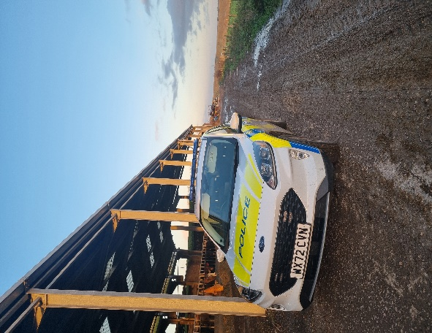
- Local officer attended the Ludgershall, Everleigh town council meeting in December, engaged with the councillors and public also discussed their concerns.

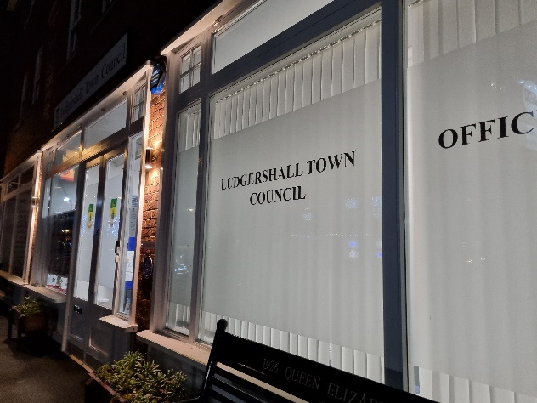
Speed Enforcement

- Tidworth Road Ludgershall- Speed Enforcement caught 7 vehicles speeding on 13 December 2024 in Ludgershall on the Tidworth Road. Unfortunately, a second site on Andover was unenforceable due to parked cars.

- Tidworth Road has a clearly displayed speed limit of 30mph. The fastest vehicle was captured travelling at 42mph. On the day in question, there was light but persistent rain and roads were wet.
Depending on previous convictions and history, 7 drivers will be offered a speed awareness course.
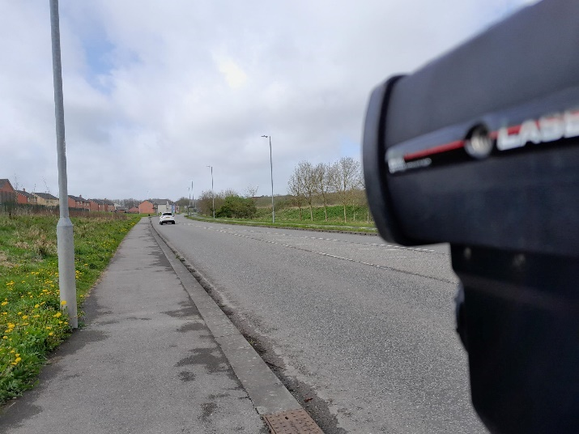

- Collingbourne Ducis- Speed Enforcement caught 15 vehicles speeding over the course of 25 minutes on 13 December 2024 in Collingbourne Ducis near the junction with Everleigh Road.
- This stretch of road has a clearly displayed speed limit of 30mph. The fastest vehicle was captured entering the village at 47mph. On the day in question, there was persistent light rain and roads were wet. The planned enforcement session had to be curtailed due to the inclement weather.
- Depending on previous convictions and history: -
12 drivers will be offered a speed awareness course
3 drivers will receive a Fixed Penalty Notice and 3 points.
Proceedings will now be undertaken to ensure the most appropriate outcome for the offenders takes place.
Priority Patrols
- Ongoing reassurance patrols around Upper Chute and Chute area for following the ASB and Nuisance reports.
- Regular reassurance foot patrols of Ludgershall for following the reports of scams and rogue traders.
- Regular reassurance patrol of Collingbourne Ducis, Churchyard for following the report of ASB.
- Ongoing reassurance patrol of Collingbourne Woods, Ludgershall for following the report of drug activities in the area.
- Ongoing reassurance patrol of Salisbury Plain for following the report of vehicle was set on fire.
- Ongoing reassurance patrol of Coombe Lane, Enford for following the report of breaking.
- Regular marked vehicle patrols targeting Rural Crime, Poaching, Fuel theft, Hare Coursing in Enford farm, COLLINGBOURNE DUCIS Farms, COLLINGBOURNE KINGSTON farms, Everleigh farms, Netheravon and Haxton farm, Enford farm.
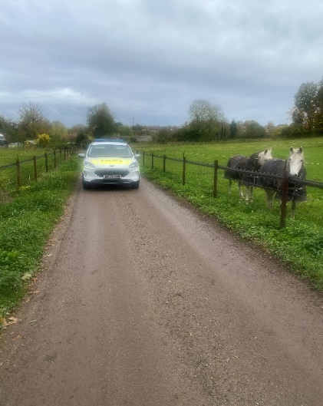

Numerous other activities have been carried out, which cannot be disclosed for operational reasons

Reporting Incidents or Intelligence

At Wiltshire Police, we have a number of ways you can report crime or incidents

- Via our online reporting hub https://www.wiltshire.police.uk/ro/report/
- Via 101 for non-emergencies and the drink drive hotline.
- Via 999 for crimes in progress and immediate threats or danger
- Via the Amesbury email inbox AmesburyAreaCPT@wiltshire.police.uk
- Directly to your Neighbourhood Policing Team via email

amesburyareanpt@wiltshire.police.uk

You can also view a crime and incident map for your area; this will show you crimes and incidents that have been reported https://www.police.uk/pu/your-area/wiltshire-police/amesbury/

