MINUTES OF THE MEEETING OF CHUTE PARISH COUNCIL
HELD ON THURSDAY 6 JUNE 2024
AT CHUTE VILLAGE HALL

52/24 OPEN FORUM
7 members of the public were present.

Mary Cummins asked if a meeting could be held to discuss the area around the bus shelter in Upper Chute. It was agreed that when Prodrainage have completed their work, and before their machinery is removed, we will ensure that parishioners are happy with the reinstatement of the area.

Alex Spurway said Prodrainage had done the residents of Tibbs Meadow a favour by clearing the area and allowing more light to the rear of their properties. She said the workforce has been courteous and helpful at all times. Kate Beale supported these comments.

Mr & Mrs Fitzgerald came to support their planning application for The Old Vicarage in Upper Chute. Questions were raised about the location and size of the swimming pool and pool house. They said the pool would be sited approximately 20m away from neighbouring properties and the size of the pool would be around 3m x 5m. The pool house would probably be situated close to their main gate. They agreed to send a more detailed specification.

Jenny Hughes asked if all green areas in Upper Chute could be discussed as the grass needs cutting, including the triangle at the top of Butts Hill.

53/24 PRESENT
Cllr Wall (Chairman), Cllr Hopton, Cllr Harker, Cllr Taylor, Cllr Alderson and Cllr Rudland were present. Cllr Williams (WCC) was present. The Clerk was in attendance.

54/24 APOLOGIES
There were apologies from Cllr Parr.

55/24 DECLARATIONS OF INTEREST
There were no declarations of interest.

56/24 MINUTES OF THE LAST MEETING
The minutes of the last meeting held on 2 May 2024 were proposed by Cllr Harker and seconded by Cllr Taylor. The minutes were then signed by the Chairman as a true record.

57/24 PLANNING
PL/2024/03783 Cross Keys Inn, Upper Chute – Variation of Condition 2 – Revised plans - support
PL/2024/04685 The Old Vicarage, Upper Chute – Two-storey extn., pool and tile removal - support
PL/2024/04517 Fosgate House, Upper Chute – swimming pool, pergola and pool house – support

The Cross Keys revised application shows an increase in size from the original pub building and dormer windows in the roof, giving the impression that it will be a larger building than the currently approved planning permission. However, Patrick Ramsey, Mr and Mrs Moore's architect, states that he had to calculate the Gross Internal Area (GIA) of the WCC approved plan because there was no published GIA shown and the comparative square footage is as follows:
Gross Internal Area:
New revised planning application 6033 square feet
Current planning permission 6052 square feet (Calculated by Mr Ramsey)
Cross Keys public house 4921 square feet

Therefore, the revised application has a slightly smaller gross internal area (GIA) than the current planning permission and the ridge height is the same, but there is an increase in GIA from the original Cross Keys building. The building will also be slightly further away from the highway and footpath, so the parish council supported the new planning application. The only additional comment was that they would prefer to see all elevations in brick and flint and did not like the ‘simplification’ of the eastern aspect.

58/24 COUNTY COUNCILLORS/WILTSHIRE POLICE REPORTS
Cllr Williams submitted his report to The Clerk prior to the meeting and it is attached to the minutes.
PCSO Rhupinder Kaur did not attend the meeting but sent in a report which is attached to these minutes.

59/24 ALLOCATION OF COUNCILLORS ROLES AND RESPONSIBILITIES
There were no changes to councillors’ roles and responsibilities.

60/24 PARISH REPORTS
Highways (TH)
Cllr Harker reported that the parish steward has cleared the verges. He has requested a that the road narrows sign on Hookwood Lane is move onto the same post as the ‘Not Suitable for Lorries’ sign on Forest Lane. The cost to the parish will be £160 which was agreed. Cllr Harker has been told that we will need to apply again to WCC to get the white lines reinstated in Upper Chute and need to prove that this is because the road was resurfaced last year and is a safety issue. Cllr Harker will make the application.
Dates for a meeting regarding the boulders on the BOAT to Gammons Farm have been supplied by Carys Ford, WCC Rights of Way, to Robin Hallam, the owner of Gammons Farm. The Clerk has requested that the parish council is notified of the meeting date if Robin Hallam would like councillors to attend.
Footpaths/Rights of Way (AR/MA)
Cllr Rudland said she had managed to arrange a meeting with Carys Ford at Cholderton Farm to obtain some signage but apart from that there was very little to report.

King George Playing Field (CW/TH)
Cllr Wall thanked volunteers who had strimmed the playing field ready for the fete. The mower had an electrical fault but is now working. Cllr Harker said there has been an increase in rubbish around the children’s play area.

Village Hall (CW)
Cllr Wall reported that she has been successful in securing £18,000 in lottery funding towards improvements at the village hall and will initially focus on sorting out the heating and replacing rotten windows.

Allotments (MT)
Cllr Taylor advised that Japanese knotweed is once again present in the pit and has been sprayed orange by WCC. A new fence is needed behind the sheds. The Leylandii trees are touching the uninsulated overhead cables so SSE should be approached to reduce them. There are Ash trees with die back in the septic tank area.
Village Design Guide (MH)
Cllr Wall said that 12 copies of the VDG have been printed and will be available in the next week or so through the parish clerks.

61/24 FINANCE
The Internal Audit took place with John Murray on13 May 24 and he commented about the verbose nature of the minutes in relation to the Open Forum and stated that length of time parishioners can speak for should be limited and that councillors should not engage in debate during this session. The concept is for items to be raised either for discussion later in the meeting if an agenda item, or added to the agenda for the next meeting. John Murray also commented on the joint insurance cover with Chute Forest Parish Council and asked if the insurers knew they were covering two parishes for Public Liability and Fidelity Guarantee elements of the policy. He also questioned whether Chute Forest Parish Council’s assets were covered by our policy. Cllr Wall advised that they are and the insurers are aware of the joint parish situation.

Cllr Wall has obtained quotes for two replacement wooden village signposts, one at the bottom of Forest Lane and the other on Lower Chute green as they are both rotten. Chute Forest PC was asked to make a contribution towards the signpost on the green in Lower Chute but have chosen to refurbish the old sign so it was agreed to only replace the one at the bottom of Hookwood Lane. The cost is £475 for a 3 finger post plus £50 delivery.
The bank reconciliation and the corresponding bank statements for May were circulated to all councillors prior to the meeting. Parish Council funds were £12,728.98 with £8,618.45 in the current account /£4,110.53 in the deposit account and reconciled to the May bank statements. The Chairman signed the bank reconciliation as a true record.

The record of payments made and received since the last meeting is as follows:

Payments Made:
03/05/2024 Clear Insurance Premium £ 789.56
03/05/2024 Simon Falla re. wellhead £ 910.44
03/05/2024 WALC Annual Subscription £ 146.58
03/05/2024 Clerks Expenses – Stationery £ 11.00
03/05/2025 KGPF Grant £2,700.00
07/05/2024 Lloyds Deposit Account re. CIL £3,900.09
07/05/2024 Lloyds Deposit Account re. Chute in Need £ 210.00
03/05/2024 VH Grant (increase/discuss) £1,000.00
27/05/2024 Clerks Salary – May £ 238.51
27/05/2024 HMRC – PAYE £ 59.40
Payments Received:
07/05/2024 Chute Cricket Club £60.00
19/04/24 CFPC Insurance £22.50
Payments for approval via online banking:
14/05/2024 John Murray – Internal Audit £ 175.00
31/05/2024 DEK Graphics – 12 x printed VDGs £113.70
27/06/2024 Clerks Salary – June £ 238.51
27/06/2024 HMRC – PAYE £ 59.58

The above payments were proposed by Cllr Harker and seconded by Cllr Taylor.
62/24 CORRESPONDENCE AND ADMINISTRATION
The Chute Chronicle has requested that only bullet points from the meetings are submitted.

Cllr Wall advised that we are waiting for the Cadley well head winding gear to be fitted to finish the job.

Cllr Wall advised that a very thorough method statement has been received from Wild Earth Ecology and Conholt Estate also has a copy. Work to carry out the pond restoration work will start on 15 July 2024.

The Clerk has now contacted the Open Space Society about registering the land at the top of Forest Lane as public open space and is awaiting their advice.

The green areas in Upper Chute need to be cut regularly throughout the summer and it is unlikely that a volunteer or a rota of volunteers can be found to cut the main green, the newly cleared area at the top of Forest Lane, the triangle at the top of Butts Hill and the triangle opposite the church. The Clerk will obtain quotes from contractors for approval at the next meeting and make a call for volunteers via the WhatApp group.

With regard to the work being undertaken by Prodrainage in Upper Chute, a main area of concern is that the new gates in the fencing that give access to the tanks for emptying need to be locked from the roadside to prevent access from the gardens. We will write to both Prodrainage and Sanctuary Housing to confirm this.

The meeting closed at 9.02 pm.

The next Meeting of Chute Parish Council will take place on
Tuesday, 2 July 2024 (due to the election on 4 July) at 7.30pm in the Village Hall

Wiltshire Councillor Report - June 2024
At a Wiltshire Council meeting on 21 May, Cllr Bridget Wayman was elected as Chairman for the forthcoming year with Cllr Christopher Newbury as Vice-Chairman.
Annual updates from Committees were then reported on highlighting the activity and key issues dealt with or covered at various council committees.
The main event was a lengthy debate regarding solar farms, some villages in the county are completely surrounded by solar farms. It was resolved that the Council would make representation to the Secretary of State for Levelling Up, Housing and Communities to define more closely what is meant by the ‘cumulative impact’ regarding solar farms and to take clear steps to ensure that solar developments are more evenly spread across the UK and not concentrated in specific area effectively industrialising the countryside. The Council also asked for clarity of the priority given to ensuring food production and farming are not destroyed as industries in specific areas through excessive concentration of solar farms given the massive impact that would have on the rural way of life in villages that have been farmed for time immemorial.
LHFIG met 5 June and the relocation of the road narrow signs was discussed. It was reported that a signage review has taken place and that the design is being finalised before being sent to Chute PC for comment.
Tidworth AB will meet Monday 24th June, 7pm at the Memorial Hall Ludgershall and there will be a drop-in event to share your view on priorities in our local community area, on Thursday 13 June at the Tidworth Civic Centre from 11am.

Christopher Williams
Wiltshire Councillor for Ludgershall North & Rural
Tel: 07712159562 Email: christopher.williams@wiltshire.gov.uk


/



EL12 Ludgershall and Rural Police Report – May 2024

- Inspector 1619 Ricky LEE
- Sergeant 2687 Caroline RALPH
- Police Constable 2054 Jody KINGE
- Police Community Support Officer 6373 Rupinder KAUR

Pro-Active Work

- Recreation Road, Ludgershall - Unknown suspect/s have used rocks to cause damage to a ground floor window in a new build property on recreation road. Window was damaged. Enquiries are still ongoing. Patrols being conducted
- Collingbourne Ducis - Unknown offender has stolen the reporting person’s leaf blower from the back on his van that was left open; value £300. Patrols being conducted.
- Ludgershall - Reporting person was walking home when she was approached by a group of teenagers who have assaulted her and taken money from her pocket. Patrols being conducted.
- Salisbury Plain - Two dogs have chased the reporting person on his bike at full speed causing the Reporting person to stop dismount and use his bike as a shield due to the dogs barking and snarling. Patrols being conducted.
- St. James Street - Unknown male and child stole roll of blue piping from reporting person’s garden. The value of the stolen item is not disclosed. Patrols being conducted.
- Linden farm, Everleigh - Dirt bikes causing issues with livestock in Linden farm. Enquiries are ongoing. Patrols being conducted.
- Red Lion, East Chisenbury - Unknown person/s have 4x 20ltr sunflower oil from the storage room at the pub Value £119.96. Enquiries are still ongoing. Patrols being conducted
- Summer down Farm- Two unknown males have been seen showing a strong interest in the nesting place of Montagu's Harriers, their activities were disturbing the nesting birds. Enquiries are still ongoing. Patrols being conducted.
- Chute - Vehicle was seen on fire in Chute, officer done the enquiries and assist with the recovery. Patrol being conducted

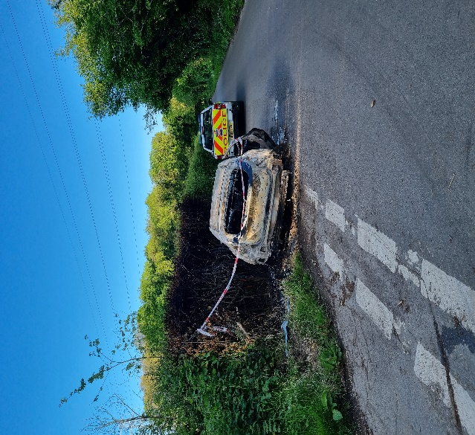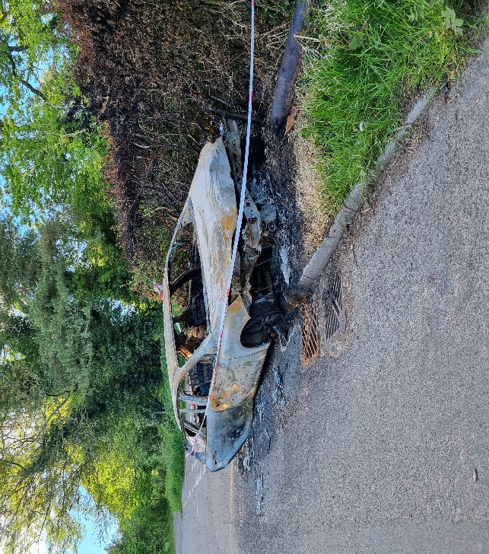

Community Engagement
- Op Sceptre - Weapon sweeps have been done in different areas: play parks Ludgershall, Collingbourne Ducis, Kingston, Netheravon, Chute, Enford, Everleigh, and Amesbury; engaging with the local community
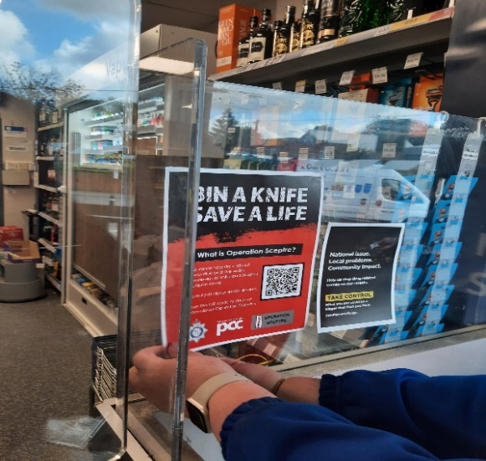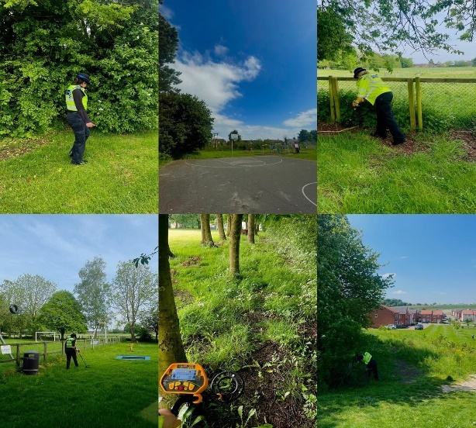
- PC and PCSO conducted foot and mobile patrols In Ludgershall, Chute, Collingbourne, Netheravon Enford, Everleigh: Engaging with Local farmers and local businesses, providing updates and a visible presence.
- PCSO HOUSE and PC DAVIES attended the coffee mornings in Ludgershall to deliver the Scam talk and engaged with the local community.
Here are some tips for helping you to protect yourself and your loved ones: -
  - Your bank or the police will never call you to ask you to verify your personal detail or PIN by phone or offer to pick up your card by courier. Hang up if you get a call like this.
  - If you need to call your bank back to check, wait five minutes; fraudsters may stay on the line after you hang up. Alternatively, use a different line altogether to call your bank.
  - Your debit or credit card is yours- Don’t let a stranger take it off you. You should only ever have to hand it over at your bank. If it’s cancelled, you should destroy it yourself
  - If you’ve given your bank detail over the phone or handed your card to a courier, call your bank straight away to cancel the card.
If you have been a victim of this type of crime and money has been lost, please report this via 101, or via the online reporting system.
If the crime is happening and in progress, please make sure that you call 999
- Officers conducted a road safety drop in Tidworth, in partnership with Wiltshire Council Road Safety Team. Members of the public were given words of advice around car seat safety and their car seats were checked by the members of the Road Safety Team.



HOW TO PREVENT "RELAY THEFT"
Use a signal-blocking pouch-

- Signal-blocking pouches are sometimes called Faraday bags or RFID signal blockers/shields. These pouches prevent the signal from your key being captured by electronic devices. It's unclear whether putting your keys in a tin box prevents potential thieves grabbing the signal. Our advice is to choose a product that has been independently tested and approved by Secured by Design.

Keep keys safe-
- A void leaving your keys near the front door as fishing for keys through the letterbox is a prominent method of stealing them. Grabbing the signal is easier for thieves if the keys are near the front door.
Disable your key fob-
- Some key fobs have a switch to turn the wireless signal off. Check your vehicle manual or ask your dealer for advice.
Use an anti-theft device-
- Consider using a physical anti-theft device like a steering wheel lock or wheel clamp. Car thieves want to get away quickly without being caught so prefer not to have to attack physical security devices.
Install a tracker-
- Tracker systems can increase the chances of recovering your vehicle if its stolen. Many systems activate once a vehicle is stolen and track it via GPS and other systems. Secured by Design can offer advice on the best system for your vehicle.
Closed circuit television (CCTV)
- As an alternative, consider installing CCTV which can be linked to your television or video to view your drive. If you do decide to use CCTV it is important to read the Information Commissioner's Office (ICO) advice on domestic CCTV systems.

Priority Patrols
- Ongoing reassurance patrols around Upper Chute and Chute area for following the ASB and Nuisance reports.
- Regular reassurance patrols of Recreation Road and surrounding areas of Ludgershall for following the report of Criminal Damage.
- Regular reassurance patrols of Enford for following the reports of vehicle has been broken into and damage been caused.
- Regular reassurance patrols of Salisbury Plain for following the reports of vehicle has been broken into and dog attacks.
- Regular reassurance patrols of Linden Farm and Summer down Farm, Everleigh for following a report of ASB.
- Regular marked vehicle patrols targeting Rural Crime, Poaching, Fuel theft, Hare Coursing in Enford farm, Collingbourne Ducis Farms, Collingbourne Kingston Southgrave farm, West Hill farm in Everleigh, Netheravon and Haxton farm.

Numerous other activities have been carried out, which cannot be disclosed for operational reasons

Reporting Incidents or Intelligence

At Wiltshire Police, we have a number of ways you can report crime or incidents

- Via our online reporting hub https://www.wiltshire.police.uk/ro/report/
- Via 101 for non-emergencies and the drink drive hotline.
- Via 999 for crimes in progress and immediate threats or danger
- Via the Amesbury email inbox AmesburyAreaCPT@wiltshire.police.uk
- Directly to your Neighbourhood Policing Team via email

amesburyareanpt@wiltshire.police.uk

You can also view a crime and incident map for your area; this will show you crimes and incidents that have been reported https://www.police.uk/pu/your-area/wiltshire-police/amesbury/

