MINUTES OF THE MEEETING OF CHUTE PARISH COUNCIL
HELD ON THURSDAY 2 JULY 2024
AT CHUTE VILLAGE HALL

63/24 OPEN FORUM
5 members of the public were present.

Stephanie Godfrey-Davies asked if a site meeting could be convened to discuss the area around the bus shelter at the top of Butts Hill. She said that children are playing on the loose earth which has recently been re-seeded. The area should not become a play area or compost heap/dumping ground.

Linda Shepherd said that water no longer drains into the soakaway and instead runs down the track to the allotments as the kerbs are at the wrong level. The site needs to be a pond again. In years gone by there used to be a sign saying No Fishing and a pole showing the depth to be 4-5 feet deep. The road drain on the right-hand side of the road by the church is currently blocked so can’t divert water into the soakaway. The parish steward will be asked to clear this.

Cllr Wall said the meeting should include a representative from Sanctuary Housing Association. The gates onto the site should be kept locked from the outside. There are pumps on the pathway and two stink pipes at one end which release gas and ar unpleasant for the adjacent properties. Overall the area is an improvement.

Mary Cummins asked if trees on the footpath through to Tibbs Meadow could be cleared by the parish steward.

64/24 PRESENT
Cllr Wall (Chairman), Cllr Hopton, Cllr Harker, Cllr Taylor, Cllr Alderson and were present. The Clerk was in attendance.

65/24 APOLOGIES
There were apologies from Cllr Parr, Cllr Rudland and Cllr Williams (WCC).

66/24 DECLARATIONS OF INTEREST
There were no declarations of interest.

67/24 MINUTES OF THE LAST MEETING
The minutes of the last meeting held on 6 June 2024 were proposed by Cllr Alderson and seconded by Cllr Taylor. The minutes were then signed by the Chairman as a true record.

68/24 PLANNING
PL/2024/04956 Star House, Hatchett Hill – replacement garage roof and demolish rear wall - Support
PL/2024/04988 Conholt House – changes to internal staircase and window surround - Support

69/24 COUNTY COUNCILLORS/WILTSHIRE POLICE REPORTS
Cllr Williams submitted his report to The Clerk prior to the meeting and it is attached to the minutes.
PCSO Rhupinder Kaur did not attend the meeting, but her report is attached to these minutes.

70/24 PARISH REPORTS
Highways (TH)
Cllr Harker reported that the parish steward has cleared the verges.
Dates for a meeting regarding the boulders on the BOAT to Gammons Farm have been supplied by Carys Ford, WCC Rights of Way, to Robin Hallam, the owner of Gammons Farm. The Clerk had suggested that Robin Hallam get in touch if he wanted a parish council presence at the meeting but no contact was made.
Footpaths/Rights of Way (AR/MA)
Chut28 – Conholt have cut this path to Home Farm but the stretch to Cadley is still very overgrown. A gate key is needed to access this stretch and the contact is Alex ?? who should be asked to deal with this.

King George Playing Field (CW/TH)
Cllr Wall said that £1,000 has been spent on the mower electrics and that now equates to over £3,000 spent on the mower this year if you include the service. It was questioned whether it would be cheaper to use a contractor. Cllr Wall thanked the fete committee for another very successful fete.

Village Hall (CW)
Cllr Wall reported that she has been successful in getting two quotes from heating consultants and will get one more. She has also obtained quotes for the replacement window casements. The coffee mornings and lunches continue to be popular and just about cover the running costs of the hall at around £300 pcm.

Allotments (MT)
Japanese knotweed has been identified in an adjacent property’s garden (No. 38 Tibbs Meadow) and needs to be sprayed off urgently before it spreads any further. Cllr Harker reported that SSE has made an application to reduce the trees in the grounds of Longview and he has given consent for access via the allotment site. Linda Shepherd said she would like to be notified of when the work is going to be undertaken and Cllr Harker said he would keep her informed.
Village Design Guide (MH)
Cllr Wall said that 12 copies of the VDG have been printed and distributed to the parish clerks who will make them available on request. Cllr Wall took one copy from the Chute allocation, so The Clerk has 5.

71/24 FINANCE
The CIL report has been submitted to WCC confirming we have received funds of £3,900.09 to date and that none of this money has yet been allocated to a specific project. It was suggested that we could plant daffodils.

The bank reconciliation and the corresponding bank statement for June was circulated to all councillors prior to the meeting. Parish Council funds were £12,203.90 with £8,088.69 in the current account and £4,115.21 in the deposit account and these figures reconciled to the June bank statements. The Chairman signed the bank reconciliation as a true record.

The record of payments made and received since the last meeting is as follows:

Payments Made:
10/06/2024 John Murray – Internal Audit £175.00
10/06/2024 DEK Graphics – 12 x VDG £113.70
27/06/2024 Clerks Salary – June £238.51
27/06/2024 HMRC – PAYE £ 59.58
Payments Received:
14/06/2024 CFPC – 6 x VDG £56.85
Payments for approval via online banking:
27/07/2024 Clerks Salary – July £238.51
27/07/2024 HMRC – PAYE £ 59.58

The above payments were proposed by Cllr Harker and seconded by Cllr Hopton.
The Withers family were thanked for mowing the greens in Upper Chute but it was felt that this should be put onto a contractual arrangement so that they are cut regularly. Simon Withers has been asked to quote.

The wooden village signpost on Lower Chute Green is going to be repaired/rebuilt by Simon Falla who has quoted £400 for the job. Chute Forest Parish Council are asking for a contribution towards the cost of £200. The lettering will be the same. This payment was proposed by Cllr Taylor and seconded by Cllr Harker.

72/24 CORRESPONDENCE AND ADMINISTRATION
Cllr Wall advised that we are still waiting for the Cadley well head winding gear to be fitted to finish the job.

Cllr Wall again advised that work to carry out the pond restoration work will start on 15 July 2024 and the surrounding area needs to be mowed/strimmed before work commences so a newt fence can be erected.

The Clerk will chase up the Open Space Society about registering the land at the top of Forest Lane as public open space as no further communication has been received since initially contacting them.

The green small green area in Chute Standen has virtually disappeared and needs to be re-seeded.

A date for an August public meeting at the area at the top of Butts Hill will be circulated in The Chute Chronical once agreed.

The meeting closed at 8.09 pm.

The next Meeting of Chute Parish Council will take place on
Thursday, 5 Sepember 2024 at 7.30pm in the Village Hall

Wiltshire Councillor Town and Parish Report July 2024
First, I must give my apologies for not being with you this evening as I am currently on holiday.
By the time you read this we will have cast our votes and a new Government with a new mandate in Westminster. Whatever the political colour of that Government there will be policy changes which will affect all of us, some good and some not so good, but that is the nature of our democracy.
Enough said on politics, on a more local level Tidworth Area Board met on 24th June and I was elected to Chair the Area Board until the end of this current Council in 2025. Main items were the Area Board End of Year Report, a presentation on the Community Area Joints Needs Assessment and the Area Board priorities for the coming year. There has been no change for last year with Health and Wellbeing, Youth and the Environment being the main issues in our community area.
Town and Parish updates were given or acknowledged, Healthwatch, NHS Integrated Care Board, Community First and a Road Safety update. There was also an excellent presentation from Kate Brooks from AGE UK Wiltshire regarding the free advice service for older people, their families, and their carers.
Grant awards were made to Castledown FM for a refreshment of studio equipment and outside broadcast facilities; Help for Heroes Military Carer Café, which supports carers in both the Armed Forces and civilian community, and Activity Sessions for the lonely and isolated in our community at the AF Equine Charity Hub.
A shorter report than normal and I look forward to being with you all after the summer break.
Christopher Williams
Wiltshire Councillor for Ludgershall North & Rural
Mob: 07712159562 Email: Christopher.williams@wiltshire.gov.uk


/



EL12 Ludgershall and Rural Police Report – June 2024

- Inspector 1619 Ricky LEE
- Sergeant 2687 Caroline RALPH
- Police Constable 2054 Jody KINGE
- Police Community Support Officer 6373 Rupinder KAUR

Pro-Active Work

- Recreation Road, Ludgershall - Unknown suspect/s have used rocks to cause damage to a ground floor window in a new build property on recreation road. Window was damaged. Enquiries are still ongoing. Patrols being conducted
- Ludgershall-Unknown suspects have caused damage to MOD fence by cutting it. Patrol being conducted.
- Princess Mary Garden, Ludgershall - Reports of unknown person setting off one firework/explosive every Saturday evenings This is disturbing residents. Patrols being conducted.
- Byron close, Ludgershall – ASB has been reported that area. Patrols being conducted.
- Linden farm, Everleigh - Dirt bikes causing issues with livestock in Linden farm. Enquiries are ongoing. Patrols being conducted.
- Everleigh - unknown suspect(s) has stolen the Reporting person’s 8ft Walter Watson roller from the. Patrols being conducted.
- Ludgershall- Local officer seized a vehicle today under proceeds of crime act as it was attempted to steal an electric bike. On a search cannabis, a slingshot, cash and two phones were seized. Patrol being conducted.

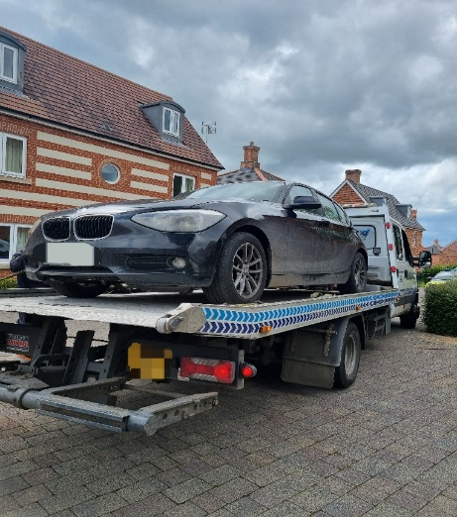
Rural Operation targeting off road Vehicles: -
Recent reports with concerns from members of public about off road driving on the Salisbury plain and the use of the byways, farms around Ludgershall and surrounding areas. Local Neighbourhood team along with the Salisbury neighbourhood team patrol the hotspots area of Ludgershall, Everleigh, Salisbury Plain where vehicle have been reported causing a nuisance. On this occasion officers are very happy to report that over four hours operation that only one vehicle required words of advice, but all other vehicles witnessed using the plain and other areas were doing so legally.



Op Scorpion -ASB foot patrol and drugs awareness leaflets have been dropped in different areas: Ludgershall, Collingbourne Ducis, Kingston, Netheravon, Chute, Enford, Everleigh, and Amesbury; engaging with the local community.

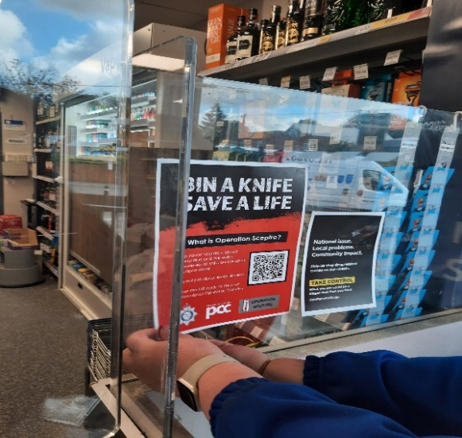
- Everleigh- Unknown suspect has climbed a telegraph pole to break a flagpole containing a pride flag off of it and the further broken the flagpole destroying the flag twice. Patrols being conducted.

Community Engagement
- PC and PCSO conducted foot and mobile patrols In Ludgershall, Chute, Collingbourne, Netheravon Enford, Everleigh: Engaging with Local farmers and local businesses, providing updates and a visible presence.
- PCSO KAUR and PC DAVIES attended the coffee mornings in Netheravon deliver the Scam talk and engaged with the local community.
- Local officers attended the Ludgershall D-Day party on recreation ground, Done the bike marking and engaged with the local community.



- PC KINGE and PC Ryan MEARS attend the Chute Fete in Chute and engaged with the local community.


- PCSO KAUR and PCSO HOUSE along with PC KINGE did the bike marking event in Netheravon also shows kids how to operate the police vehicle.

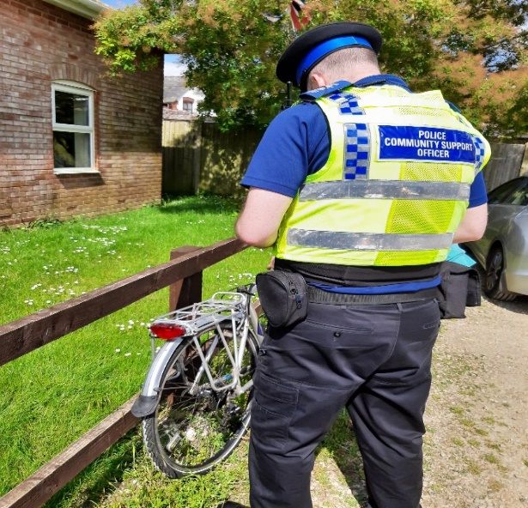

- PCSO KAUR attended the Enford Fete and engaged with the local community.

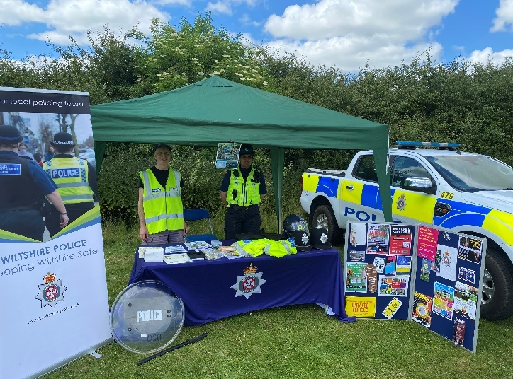

Speed Enforcement

Collingbourne Kingston -Speed Enforcement caught 5 vehicles speeding on 21 June
2024 in Collingbourne Kingston near the Cuckoo Pen.
This stretch of road has a clearly displayed speed limit of 30mph. The fastest vehicle was captured travelling at 40mph. On the day in question, it was bright and dry.
Depending on previous convictions and history all 5 drivers will be offered a speed awareness course.
- Collingbourne Ducis - Speed Enforcement caught 17 vehicles speeding on 21 June 2024 in Collingbourne Ducis near the Everleigh Road.
This stretch of road has a clearly displayed speed limit of 30mph. The fastest vehicle was captured travelling at 42mph. On the day in question, it was bright and dry.
Depending on previous convictions and history, all 17 drivers will be offered a speed awareness course.
Ludgershall- Speed Enforcement caught 16 vehicles speeding on 21 June 2024 in Ludgershall on the Tidworth Road.
This stretch of road has a clearly displayed speed limit of 30mph. The fastest vehicles were captured travelling at 43mph. On the day in question, it was sunny and roads were dry.
Depending on previous convictions and history: -
14 drivers will be offered a speed awareness course
2 drivers will receive a Fixed Penalty Notice and 3 points.
Proceedings will now be undertaken to ensure the most appropriate outcome for the offenders takes place.
Priority Patrols
- Ongoing reassurance patrols around Upper Chute and Chute area for following the ASB and Nuisance reports.
- Regular reassurance patrols of Recreation Road and surrounding areas of Ludgershall for following the report of Criminal Damage.
- Regular reassurance patrols of Salisbury Plain for following the reports of vehicle has been causing nuisance.
- Regular reassurance patrols of Linden Farm and Summer down Farm, Everleigh for following a report of ASB and criminal damage.
- Regular marked vehicle patrols targeting Rural Crime, Poaching, Fuel theft, Hare Coursing in Enford farm, Collingbourne Ducis Farms, Collingbourne Kingston Southgrave farm, West Hill farm in Everleigh, Netheravon and Haxton farm.

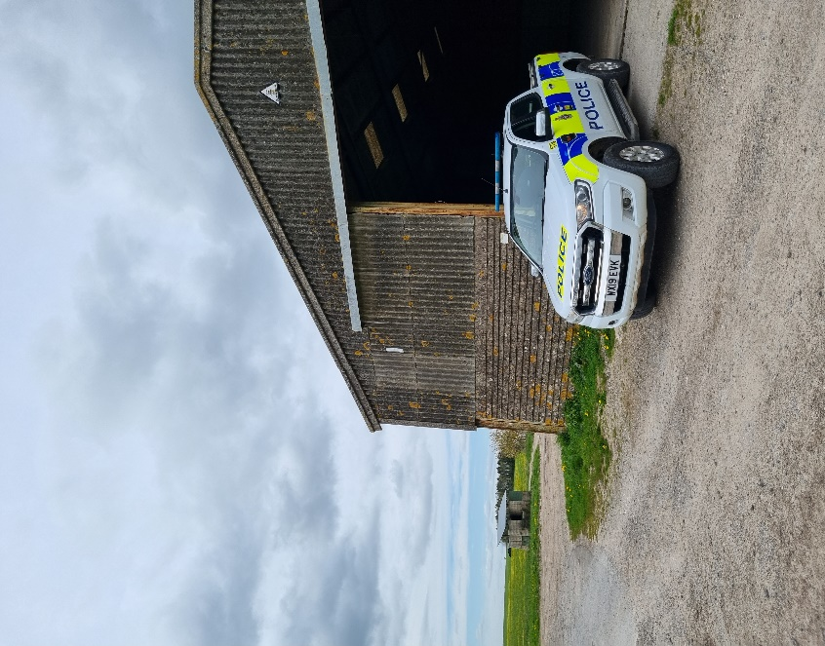

Numerous other activities have been carried out, which cannot be disclosed for operational reasons

Reporting Incidents or Intelligence

At Wiltshire Police, we have a number of ways you can report crime or incidents

- Via our online reporting hub https://www.wiltshire.police.uk/ro/report/
- Via 101 for non-emergencies and the drink drive hotline.
- Via 999 for crimes in progress and immediate threats or danger
- Via the Amesbury email inbox AmesburyAreaCPT@wiltshire.police.uk
- Directly to your Neighbourhood Policing Team via email

amesburyareanpt@wiltshire.police.uk

You can also view a crime and incident map for your area; this will show you crimes and incidents that have been reported https://www.police.uk/pu/your-area/wiltshire-police/amesbury/

